Multi-Dimensional Framework for Clinical Diabetes Prediction: External Validation and Fairness Analysis
Rajveer Singh Pall
Computer Science and Business Systems
Jabalpur Engineering College
Jabalpur, Madhya Pradesh, India
rajveerpall05@gmail.com
ABSTRACT
Background and Objective: Machine learning models for predicting Type 2 diabetes have increased in number recently. Many report impressive metrics, with area under the curve (AUC) values over 0.85. However, these models often fail to show real-world effectiveness because of three critical issues: insufficient external validation on independent populations, lack of assessment of clinical utility beyond discrimination metrics, and inadequate evaluation of fairness across different demographic groups. This study aims to tackle these issues by creating and demonstrating a detailed evaluation framework for clinical prediction models, using diabetes prediction as a practical example.
Methods: We conducted a pre-registered, prospective validation study following TRIPOD+AI reporting guidelines. We used a three-tier dataset strategy: (1) The National Health and Nutrition Examination Survey (NHANES) 2015-2020 (n=15,685 participants) for model development and internal validation through nested 5-fold cross-validation, (2) The Behavioral Risk Factor Surveillance System (BRFSS) 2020-2022 (n=1,282,897 participants) as a completely independent external validation cohort reflecting real-world conditions, and (3) The Pima Indians Diabetes Dataset (n=768) for benchmark comparisons with existing literature. We compared four machine learning algorithms—XGBoost, Random Forest, Logistic Regression, and Support Vector Machine—using eight non-laboratory predictors: age, gender, race/ethnicity, body mass index, smoking status, physical activity, history of heart attack, and history of stroke. We assessed model performance across six critical areas: discrimination (AUC, sensitivity, specificity), calibration (Brier score, reliability diagrams), clinical utility (decision curve analysis), interpretability (SHAP values), fairness (demographic stratification with statistical testing), and cost-effectiveness (incremental cost-effectiveness ratios).
Results: In internal validation on NHANES data, XGBoost achieved the highest mean AUC of 0.795 (95% CI: 0.788-0.807), followed closely by Logistic Regression (0.792) and Random Forest (0.789), with no significant differences among the top three algorithms. However, when we evaluated the final XGBoost model on the independent BRFSS cohort, performance significantly dropped to an AUC of 0.717, reflecting a decrease of 0.078 points. This performance decline was coupled with poor calibration, shown by a Brier score of 0.124, indicating an overestimation of diabetes risk. Specificity fell from 65.7% to 50.2%, and positive predictive value dropped from 35.2% to 19.8%. This meant that four out of five patients identified as high-risk were actually false positives. Despite these statistical limitations, decision curve analysis showed that the model offers meaningful clinical benefit, yielding a net benefit of 0.08 at the clinically relevant 10% risk threshold—equating to correctly identifying 8 additional at-risk individuals per 100 patients without boosting unnecessary interventions. Fairness analysis revealed critical age-related bias: the model's performance was unacceptable for patients 60 years and older (AUC 0.607, only slightly better than random chance), while performance was equitable across genders (males 0.712 vs females 0.723, p=0.565). Racial fairness analysis was severely hindered by 44.2% missing ethnicity data in the BRFSS cohort, making reliable conclusions impossible. SHAP interpretability analysis showed that Age and BMI were the most significant predictive features, which aligns with existing clinical knowledge. Surprisingly, a simpler model using only these two features outperformed the full eight-feature model in external validation (AUC 0.748 vs 0.717). This suggests that adding more features introduced noise rather than value in the new scenario.
Conclusions: This study reveals three important insights for healthcare artificial intelligence. First, internal validation performance often overstates real-world effectiveness; our observed 0.078 AUC drop might reflect broader trends in the field. External validation on independent populations is essential for any model aimed at clinical use. Second, clinical utility and statistical performance are different concepts. Even with poor calibration and reduced discrimination, the model shows positive net benefits for clinical decision-making as indicated by decision curve analysis. This "imperfect but useful" idea challenges the focus on maximizing AUC scores. Third, fairness must be explicitly verified; the noted age-related performance decline (AUC 0.607 for elderly patients) signifies a bias that would disadvantage high-risk populations. The evaluation framework we present here—integrating pre-registration, thorough external validation, calibration evaluation, clinical utility measurement, and fairness analysis—offers a reusable method for ethical clinical AI development.
Clinical and Policy Implications: Before this or any similar model can be used in clinical practice, three requirements must be met: (1) recalibration using techniques like isotonic regression to adjust for systematic risk overestimation, (2) age-stratified model development or recalibration to ensure fair performance for older populations, and (3) ongoing performance monitoring with set thresholds for model retraining. This framework could guide future guidelines for healthcare AI regulation and implementation.
________________________________________
INDEX TERMS
Machine learning, diabetes mellitus prediction, external validation, clinical decision support systems, algorithmic fairness, model calibration, decision curve analysis, XGBoost, gradient boosting, healthcare artificial intelligence, interpretable machine learning, SHAP values, health equity, real-world evidence, NHANES, BRFSS, population health screening, Type 2 diabetes, risk stratification, predictive modeling
________________________________________
I. INTRODUCTION
Type 2 diabetes mellitus is one of the major and rapidly growing global health challenges for healthcare systems worldwide. The International Diabetes Federation estimates that around 537 million adults aged 20-79 were living with diabetes in 2021, with numbers expected to rise to 783 million by 2045. This situation poses not just a clinical challenge but also a massive economic burden, with global healthcare expenditures for diabetes reaching USD 966 billion in 2021. The disease leads to severe issues for individuals, increasing their risk of cardiovascular disease, kidney failure, blindness, and lower limb amputations. Healthcare systems face difficulties in allocating resources for an increasingly common chronic condition, and societies bear the economic costs related to decreased productivity and premature death.
The natural progression of Type 2 diabetes presents a vital chance for intervention. The disease generally develops gradually over several years, moving through identifiable pre-diabetic states marked by impaired fasting glucose and glucose tolerance. During this pre-diabetic phase, lifestyle changes like diet modification, more physical activity, and weight loss can lower the risk of progressing to full diabetes by 40-70%. Similarly, medications like metformin can reduce diabetes incidence by around 30% in high-risk individuals. The success of these preventive methods relies heavily on one critical factor: the timely identification of at-risk individuals before permanent pancreatic beta-cell damage and complications begin. Early identification allows targeted interventions when they are most effective and efficient.
Machine learning has emerged as a promising approach for developing predictive models that identify individuals at higher risk of developing diabetes. Over the last decade, research has exploded in this area, with numerous studies applying various supervised learning algorithms—including logistic regression, decision trees, random forests, support vector machines, neural networks, and gradient boosting methods like XGBoost—to predict diabetes onset using various combinations of demographic, clinical, and laboratory data. These studies often report impressive performance metrics, with area under the receiver operating characteristic curve (AUC) values commonly over 0.85 and sometimes reaching 0.90 or even 0.95. Such positive results have generated strong enthusiasm in both the research community and popular media regarding the potential for artificial intelligence to transform diabetes screening, prevention, and early detection.
However, a significant gap exists between these encouraging research findings and actual clinical use. Despite thousands of published machine learning models for diabetes prediction, very few have successfully transitioned into routine clinical practice or large-scale application in real-world healthcare settings. This gap between research promise and clinical reality isn't unique to diabetes prediction but reflects wider challenges in healthcare artificial intelligence. A systematic review of the literature shows several recurring methodological flaws that may explain this translational failure and diminish trust in reported model performance.
First, there is a strong reliance on small, demographically limited datasets. The most commonly used benchmark dataset for diabetes prediction is the Pima Indians Diabetes Dataset, which has been used in hundreds of studies since its creation in 1988. While this dataset has been valuable for developing algorithms, it represents only 768 individuals, all of whom are female, from a single Native American ethnic group (Pima Indians of Arizona) in a specific area. Models trained and validated solely on such narrow, homogeneous populations cannot realistically be expected to generalize to the diverse populations found in real-world clinical settings. The factors influencing diabetes risk, such as demographics, genetics, environment, and socioeconomic status, vary widely across groups. Yet this issue of population representativeness is often inadequately addressed in the literature.
Second, and perhaps most importantly, most diabetes prediction studies lack rigorous external validation on truly independent datasets. A recent systematic review found that only about 15% of published diabetes prediction models were tested on completely independent datasets from different populations, time periods, or healthcare systems. The other 85% of studies rely solely on internal validation techniques, such as k-fold cross-validation, bootstrap resampling, or simple train-test splits within a single dataset. Although internal validation is necessary to check for overfitting and optimize model settings, it tends to provide an overly optimistic view of model performance. This is because the validation data, even though it is set aside during training, comes from the same population, collection methods, and timeframe as the training data. This approach fails to assess the model's ability to generalize under changing conditions, such as shifts in patient demographics, clinical measurement practices, data quality, and healthcare contexts that occur when models are used in new settings. Studies that conduct true external validation consistently report a significant drop in performance, with AUC values usually falling by 0.05 to 0.15 points compared to internal validation results. This issue, sometimes referred to as "algorithm optimism," suggests that the impressive metrics seen in the literature may greatly overstate real-world effectiveness.
Third, many diabetes prediction studies focus solely on discrimination metrics like AUC, sensitivity, and specificity, while overlooking other key aspects of model performance. While discrimination—correctly ranking patients by risk—is important, it doesn’t fully capture a model's clinical value or readiness for use. Two additional dimensions often ignored are calibration and clinical utility. Calibration, or how well predicted probabilities match actual outcomes, determines whether the risk scores from a model are trustworthy and can be clearly communicated to both patients and healthcare providers. A poorly calibrated model may correctly rank patients while offering biased probability estimates, which can result in inappropriate clinical decisions and patient anxiety. Clinical utility measures whether a model actually improves outcomes compared to default strategies, rather than just achieving statistical significance. Decision curve analysis, developed to evaluate clinical utility, assesses the trade-offs between benefits and harms at various risk thresholds. Fewer than 20% of diabetes prediction studies assess clinical utility or calibration, leaving essential questions about whether models would truly enhance care if put into practice.
Fourth, while interpretability and fairness are increasingly recognized as important aspects of healthcare AI, their analysis in diabetes prediction research is often superficial or lacking. Understanding why a model makes specific predictions is vital for building trust, identifying potential errors, and ensuring clinical validity. Modern tools like SHAP can show which features influence predictions and whether models rely on sensible patterns or spurious correlations. However, such analyses are rare in published research. There is also insufficient attention to algorithmic fairness—the idea that models should perform equally well across different demographic groups and should not worsen existing health disparities. Diabetes risk, disease progression, and treatment response differ among racial and ethnic groups due to complex interactions involving genetic factors, socioeconomic status, access to healthcare, and environmental influences. Models primarily trained on majority populations may underperform for minority groups, thus widening health inequalities. Despite these concerns, comprehensive fairness assessments—evaluating performance across age, gender, race, and socioeconomic status—are conducted in fewer than 10% of studies on diabetes prediction. This gap is particularly alarming given the growing evidence of algorithmic bias in several healthcare AI applications.

The current study addresses important gaps in methodology by creating and demonstrating a thorough evaluation framework for clinical prediction models. Using Type 2 diabetes prediction as a practical example, we offer a clear template for responsible healthcare AI development that other researchers can use for different clinical prediction tasks. Our framework includes five key innovations:

1. Pre-registration and open science practices: To reduce publication bias and selective reporting, we pre-registered our full study protocol, which includes planned analyses and evaluation metrics, on the Open Science Framework before doing any analyses. This approach, common in clinical trials but rare in machine learning research, ensures transparency and stops post-hoc justification of methods.

2. Three-tier dataset strategy with strict external validation: We used NHANES (National Health and Nutrition Examination Survey) data for model development and internal validation. For external validation, we employed a larger and completely independent dataset from BRFSS (Behavioral Risk Factor Surveillance System). Finally, we used the standard PIMA benchmark dataset for comparison with published literature. Importantly, the BRFSS external validation dataset was completely set aside until we locked the final model, eliminating any chance of information leakage that could inflate performance estimates.

3. Multi-dimensional performance evaluation beyond AUC: We carefully assessed six key dimensions: discrimination (AUC, sensitivity, specificity), calibration (Brier score, reliability diagrams), clinical utility (decision curve analysis), interpretability (SHAP values), fairness (stratified performance with statistical testing), and cost-effectiveness.

4. Extensive fairness analysis with open reporting of limitations: We analyzed model performance across demographic subgroups (age, gender, race/ethnicity) and clearly reported our findings, along with limitations, including data quality issues that affect some conclusions.

5. Practical implementation considerations: Beyond statistical evaluation, we offer practical advice on calibration correction methods, criteria for readiness before deployment, and ongoing monitoring requirements.

The rest of this paper is organized as follows. Section II reviews relevant work in diabetes prediction, external validation, assessment of clinical utility, and algorithmic fairness. Section III details our methodology, including dataset descriptions, preprocessing steps, model development using nested cross-validation, and detailed evaluation protocols. Section IV presents results across all evaluation dimensions, notably highlighting substantial performance drops in external validation. Section V discusses the implications of our findings for healthcare AI development, clinical applications, and health equity. Section VI concludes with suggestions for future research and policy.

Through this work, we aim to show that clinical prediction models can offer meaningful clinical utility despite statistical flaws, but only when evaluated through rigorous, multi-dimensional frameworks that honestly assess real-world performance and potential harm. Our findings challenge the common focus on maximizing internal validation AUC scores and instead stress the importance of external validation, clinical utility, calibration, and fairness as equal priorities for responsible healthcare AI development.

A. Machine Learning for Diabetes Prediction
Using machine learning to predict Type 2 diabetes onset has been an active research area for over thirty years, with a significant increase in publications over the last decade. Early studies, such as the 1988 paper by Smith et al., introduced the ADAP (Adaptive Learning Routine) algorithm applied to what became the widely-used Pima Indians Diabetes Dataset. This dataset, which includes 768 female patients of Pima Indian heritage with eight clinical and demographic features, has since become a benchmark for algorithm comparison in many studies.

A systematic literature review by Rahman et al. analyzed 48 studies published between 2015 and 2021, offering valuable insights into the current state of the field. The review found that researchers have examined nearly every major category of supervised learning algorithms for diabetes prediction. Traditional statistical methods like logistic regression and Cox proportional hazards models provide interpretability and solid statistical properties, but may have difficulty capturing complex non-linear relationships and high-order feature interactions. Instance-based methods like k-Nearest Neighbors (k-NN) have been explored, with some studies showing competitive performance, yet these methods struggle with large datasets and require careful feature scaling and distance metric choices. Tree-based methods, including standalone decision trees, random forests, and gradient boosting techniques like XGBoost and LightGBM, have grown in popularity due to their ability to model non-linear relationships, handle mixed data types effectively, and offer built-in feature importance measures. Support vector machines with various kernels (linear, polynomial, radial basis function) have also been extensively studied, although their performance advantages are often minor in clinical tabular data. Neural network approaches, from basic multi-layer perceptrons to advanced deep learning architectures, have been examined, but their performance improvements seldom justify their computational costs and reduced interpretability when used with traditional tabular data with limited sample sizes.

Performance metrics reported in this literature appear overly optimistic and raise methodological concerns. Rahman et al.'s systematic review found that internal validation AUC values generally ranged from 0.85 to 0.95 across different algorithms and feature sets, with some studies reporting near-perfect discrimination (AUC > 0.95). Random forests and gradient boosting methods seemed to perform slightly better than others in meta-analyses, although differences were often small and statistically insignificant. However, several critical methodological issues severely limit the interpretability and generalizability of these findings.

First, most studies rely on small, publicly available datasets, especially the 768-patient Pima dataset. While standard benchmarks make algorithm comparison easier, the Pima dataset has critical limitations: it has a small sample size (which limits statistical power and generalizability), demographic homogeneity (only female Pima Indians), data quality issues (including implausible values for some variables), and significant missing data for some features. Models trained solely on this dataset cannot be assumed to apply broadly to different populations with varied genetic backgrounds, environmental exposures, healthcare systems, and socioeconomic contexts. Few studies have used larger, more diverse datasets like electronic health records, and those typically do not make their data publicly available due to privacy concerns, which limits reproducibility and independent validation.

Second, feature engineering approaches differ widely among studies, making direct comparisons hard. Some studies only include basic demographic variables (age, gender, BMI), while others use extensive laboratory values (fasting glucose, HbA1c, lipid panels), genetic markers, dietary questionnaires, or even free-text clinical notes processed through natural language processing. This variability makes it challenging to determine if performance differences are due to algorithmic superiority or simply accessing more informative features. When laboratory values are included, they often dominate model predictions, achieving AUC values above 0.90 even with simple logistic regression, raising questions about whether complex algorithms offer any real benefit. However, laboratory-dependent models have practical deployment challenges, as they cannot be used for population-level screening where laboratory data are not available. Models relying only on non-laboratory features tend to have lower performance (AUC 0.75-0.85), indicating a trade-off between prediction accuracy and practical applicability.

Third, and most critically, external validation is rare, and performance drops are common when it is attempted. Rahman et al.'s review found that fewer than 20% of studies conducted any form of external validation, and only about 10-15% tested their models on completely independent datasets from different populations or healthcare systems. Most studies rely solely on internal validation through k-fold cross-validation, holdout validation sets, or bootstrap resampling within a single dataset. While these techniques are useful for hyperparameter tuning and checking for overfitting, they do not account for performance drops due to distribution shifts—changes in patient demographics, data collection methods, or clinical contexts that occur when models are applied in new situations.

A few notable exceptions that have implemented rigorous external validation consistently show substantial performance drops. A study by Lai et al. developed a diabetes prediction model using electronic health records from one healthcare system (with an internal AUC of 0.89) and tested it on data from a different healthcare system, finding a drop to an AUC of 0.76—an overall decrease of 0.13 points. Similarly, research applying models trained on Western populations to Asian populations has reported even larger performance declines, sometimes exceeding 0.20 AUC points, due to differences in diabetes pathophysiology, risk factor distributions, and BMI thresholds among ethnic groups. These findings suggest that the high internal validation metrics often reported in the literature significantly overestimate real-world model effectiveness, which is what our study aims to quantify and understand.

Fourth, most studies lack a thorough analysis of model interpretability and feature importance. While many papers list which features were included in their models, few deeply examine how these features impact predictions or whether their contributions align with clinical knowledge. Additionally, it is uncommon for studies to check whether models exploit misleading correlations. Tree-based methods do provide feature importance metrics (like Gini importance for random forests or gain-based importance for XGBoost), but these global measures do not show how features interact or how individual predictions are made. Modern interpretability techniques like SHAP (SHapley Additive exPlanations) can offer global feature importance rankings and local explanations for specific predictions, revealing whether models rely on clinically relevant patterns. However, SHAP analysis is still rare in published diabetes prediction studies, leaving important questions about model behavior and reliability unanswered.

B. External Validation in Healthcare ML
The critical need for external validation in clinical prediction models has gained more attention over the past decade, but it is still implemented disappointingly rarely. External validation, which tests a model on data that is completely independent from the development dataset, ideally from a different population, time period, or healthcare setting, is crucial for assessing true generalizability and detecting performance drops due to distribution shifts.

Dataset shift is one of the most significant challenges for deploying machine learning models in healthcare and other real-world areas. Dataset shift occurs when the statistical distribution of features, outcomes, or their relationships differs between the training and deployment settings. Several types of distribution shift apply to clinical prediction models. Covariate shift happens when the distribution of input features (like patient demographics or clinical measurements) changes while the relationship between features and outcomes stays stable. For instance, a model trained on a younger population might be applied to an older population. Prior probability shift (also called label shift) occurs when the prevalence of an outcome changes—like when a model trained on a high-risk group is used for general population screening. Concept drift happens when the actual relationship between features and outcomes changes over time, such as when treatment practices change, rendering historical data less relevant for predicting future outcomes.

Healthcare environments are particularly vulnerable to all types of dataset shifts due to the diverse nature of patient populations, variations in clinical practice among institutions, changes in treatment protocols over time, and differences in data collection and coding practices across healthcare systems. A model trained at a large academic medical center serving mainly insured urban patients may perform poorly when implemented at a rural community hospital serving uninsured patients with different risk factor profiles and comorbidity patterns. Likewise, models trained on carefully curated research datasets may falter when applied to real-world electronic health records, which often have missing data, measurement errors, and inconsistent coding practices.

A systematic review by Zhang et al. examined external validation in machine learning studies for diabetes prediction, analyzing 112 published studies from 2010 to 2021. The results were disheartening: only 17 of the 112 studies (15.2%) conducted any form of external validation, and many that did employed weak designs, like temporal validation using later data from the same institution rather than truly independent geographic or institutional validation. The remaining 95 studies (84.8%) relied entirely on internal validation methods.
Even more concerning, in studies that conducted external validation, performance decline was almost universal and often significant. The median AUC drop from internal to external validation across these studies was 0.089, with individual studies reporting drops as small as 0.03 to as high as 0.24 points. These results strongly indicate that the optimistic performance metrics reported based solely on internal validation—dominant in current literature—systematically overestimate real-world model performance. This "optimism bias" has serious implications. It raises expectations about model usefulness, could lead to premature deployment of unreliable models, and ultimately erodes trust in healthcare AI when deployed models fail to perform as expected.

Several factors contribute to this performance decline. Differences in patient populations between training and deployment sites lead to shifts in covariates, with models encountering feature value combinations or patient profiles that are underrepresented or absent in training data. Variations in measurement protocols and data quality among institutions create systematic biases that models cannot adjust to. For instance, blood pressure measurements taken with different devices or procedures, laboratory values processed by different machines, or clinical variables recorded using different standards can all hurt model performance. Temporal changes occur as disease patterns, risk factors, and treatment methods evolve, making historical training data less representative of current clinical situations. Geographic and cultural differences influence both risk factor distributions, like dietary habits and physical activity levels, and healthcare usage patterns, such as screening practices and treatment adherence.

Best practices for external validation have been established in several reporting guidelines, notably TRIPOD (Transparent Reporting of a multivariable prediction model for Individual Prognosis Or Diagnosis) and its recent update TRIPOD+AI, which specifically addresses machine learning models. These guidelines advise that external validation should use completely independent datasets, ideally from different geographic locations, healthcare systems, or time periods. The validation dataset should remain separate during model development. It should never be examined or used for feature selection or hyperparameter tuning, to ensure an unbiased estimate of generalization performance. When external validation shows a decline in performance, models should be recalibrated or updated with data from the target population before they are deployed. Ongoing performance monitoring should be carried out after deployment to identify further changes over time.

Despite clear guidelines and overwhelming evidence of performance decline, external validation is still rare in practice. Barriers include limited access to multiple independent datasets due to data sharing restrictions and privacy laws, the extra time and resources needed for multi-site collaborations, reluctance to report negative results (performance drops) that could hurt publication chances, and a lack of awareness among some researchers about the critical need for external validation compared to internal cross-validation.

Our study directly addresses this critical gap by implementing rigorous external validation using a completely held-out dataset (BRFSS with over 1.28 million participants) that is not only independent but also shows significant distributional differences from the training data (NHANES). These differences include varying data collection methods (standardized clinical examinations versus telephone surveys), different sampling frames, and different time periods. This design allows us to measure the performance decline that occurs under realistic deployment conditions and understand which types of distribution shifts most affect model performance.

While discrimination metrics such as AUC, sensitivity, and specificity are commonly reported in clinical prediction model studies, they do not paint a complete picture of a model's clinical value. A model can show excellent discrimination (high AUC) without offering any clinical benefit, or it may have modest discrimination yet greatly enhance clinical decision-making. This disconnect occurs because discrimination metrics assess the model's ability to rank patients from lowest to highest risk but do not directly measure whether using the model to guide treatment decisions leads to better outcomes than other strategies.

Decision curve analysis (DCA), introduced by Vickers and Elkin in 2006, was created to tackle this limitation by measuring the clinical usefulness of prediction models. DCA calculates the "net benefit" of using a model to inform decisions across a range of clinically relevant risk thresholds. It accounts for both the advantages of true positive classifications (correctly identifying high-risk patients who should receive intervention) and the drawbacks of false positive classifications (subjecting low-risk patients to unnecessary interventions).

The key insight behind DCA is that clinical decisions require balance among competing factors. In diabetes screening, for instance, identifying a genuinely at-risk individual allows for preventive measures (like lifestyle changes or metformin) that can lower disease incidence. However, wrongly categorizing a low-risk individual as high-risk causes unnecessary stress, extra clinic visits, lab tests, and possibly medication side effects. The best balance between these concerns depends on the risk threshold at which clinicians decide to intervene. This decision varies based on intervention costs, potential benefits, patient preferences, and healthcare system resources.

The formula for net benefit explicitly captures this trade-off:
Net Benefit = (True Positives / N) - (False Positives / N) × [pt / (1 - pt)]
where N represents the total population, and pt is the risk threshold for recommending intervention. The weighting factor [pt / (1 - pt)] reflects the relative harm of false positives versus false negatives at a particular threshold. At low risk thresholds (e.g., 5% risk for recommending lifestyle counseling), false positives are more tolerable since the intervention is low-cost and low-risk, so the weighting factor is small. At high risk thresholds (e.g., 40% risk for recommending expensive or risky interventions), false positives are more problematic, making the weighting factor larger.

DCA compares the net benefit of using a prediction model against two default strategies: "treat all" (intervene on everyone regardless of risk) and "treat none" (intervene on no one). A model is considered clinically useful if its net benefit curve exceeds both default strategies across relevant risk thresholds. The distance between the model's curve and the default strategies indicates the level of clinical benefit. For example, a net benefit of 0.08 at a 10% risk threshold means that using the model leads to 8 more true positives per 100 patients without increasing the false positive count, compared to treating no one.

Decision curve analysis has several key advantages over traditional performance metrics. First, it integrates clinical context through the risk threshold parameter, recognizing that the same model may be helpful at some thresholds but not at others. Second, it takes into account both false positives and negatives using clinically relevant weights rather than assuming they are equally important. Third, it offers intuitive insights into whether and how much a model improves clinical decision-making compared to simple default strategies. Fourth, DCA can evaluate multiple models or combine models with other clinical information.

Despite these advantages and the availability of DCA methodology for nearly two decades, its use in diabetes prediction literature has been disappointingly slow. A systematic review by Rahman et al. found that fewer than 20% of diabetes prediction studies from 2015 to 2021 included any form of clinical utility assessment, and less than 10% specifically used decision curve analysis. Most studies only report discrimination metrics (AUC, sensitivity, specificity), implicitly assuming that higher discrimination automatically means greater clinical value—an assumption that has been repeatedly shown to be incorrect.

This gap is especially troubling because discrimination and clinical utility can diverge. A model with excellent discrimination (high AUC) may have little clinical utility if its performance just surpasses the "treat all" strategy at relevant risk thresholds. Conversely, a model with modest discrimination may offer significant clinical utility if it successfully identifies a group of high-risk individuals who benefit from intervention while avoiding unnecessary treatments for low-risk individuals. Calibration—how closely predicted probabilities align with observed outcomes—also significantly affects clinical utility, as poorly calibrated models may lead to inappropriate decision thresholds even if discrimination is good.

Calibration assessment, while different from clinical utility analysis, is closely linked and similarly underutilized in diabetes prediction literature. Calibration checks if predicted probabilities are reliable—whether patients who are predicted to have a 30% risk actually experience outcomes around 30% of the time. Poor calibration raises several problems: undermining trust in communicating risk to both patients and clinicians, potentially leading to inappropriate treatment decisions if thresholds are set based on unreliable probabilities, and indicating that the model may not reflect the actual data-generating process.

Standard calibration metrics include the Brier score (the mean squared difference between predicted probabilities and actual outcomes, with lower values indicating better calibration), calibration slope and intercept from regression of outcomes on predicted probabilities, and visual assessments through calibration plots (reliability diagrams) that display predicted versus observed risk across deciles of predicted probability. Well-calibrated models show agreement between predicted and actual risks, while poorly calibrated models either systematically over-predict (predictions consistently higher than observations) or under-predict (predictions consistently lower than observations).

Importantly, calibration and discrimination are distinct and independent measures. A model can rank patients perfectly while being poorly calibrated or can be well-calibrated while struggling to distinguish between high- and low-risk groups. Both aspects are necessary for optimal clinical usefulness. Models with poor calibration can often be recalibrated using post-hoc techniques such as Platt scaling (fitting a logistic regression to model outputs) or isotonic regression (fitting a monotonic function between predicted and observed probabilities), although this requires additional calibration data from the target population.

Our study addresses the lack of focus on clinical utility and calibration in diabetes prediction literature by incorporating both decision curve analysis and thorough calibration assessment as key components of our evaluation framework. We clearly quantify whether our model offers net clinical benefit compared to default strategies and identify the risk thresholds where the model is effective. We also assess the quality of calibration, pinpoint systematic biases, and show how post-hoc recalibration methods can enhance model reliability before deployment. This comprehensive approach guarantees that our conclusions about model usefulness are based on clinically relevant outcomes rather than just statistical measures.
D. Fairness and Bias in Healthcare AI

The understanding that machine learning algorithms can sustain or even worsen existing societal biases and health disparities is a significant ethical concern in healthcare artificial intelligence. It is essential for clinical prediction models to work fairly across different demographic groups, including various racial and ethnic backgrounds, age groups, genders, socioeconomic statuses, and geographic areas. This is not just a technical issue; it is a fundamental requirement for ethical and responsible healthcare AI development.

The sources of algorithmic bias in healthcare are varied and often subtle. First, training data may not adequately represent the entire population that models will serve. If certain demographic groups are underrepresented in training datasets—due to past exclusion from research, unequal access to healthcare, or sampling biases—models may learn patterns that do not apply well to these groups. This issue is especially prominent for racial and ethnic minorities, who have often been underrepresented in clinical research and whose health conditions may differ from those of majority populations.

Second, clinical measurements and diagnostic practices may be biased, and models trained on these biased data will inherit and possibly amplify these biases. For example, if minority patients are less likely to receive certain tests because of systemic healthcare inequalities, the training data will not accurately reflect the true disease prevalence in these populations. This could lead to models underestimating risk for minority individuals. A notable example involved a widely-used commercial algorithm meant to identify patients needing extra healthcare resources. This algorithm was found to systematically disadvantage Black patients because it used healthcare costs as a substitute for health needs, and Black patients typically receive lower-cost care due to systemic inequalities, not because they have lower health needs.

Third, features used in prediction models can act as stand-ins for protected demographic attributes, even when those attributes are not directly included. This is known as "redundant encoding." For instance, ZIP codes may strongly correlate with race due to residential segregation, allowing models to make race-based predictions even without explicit race data. Using such proxy variables can lead to biased predictions that breach anti-discrimination principles while still complying with rules against using protected attributes.

Fourth, issues of fairness become especially complicated in healthcare because biological and genetic factors genuinely affect disease risk across demographic groups. For example, the risk of Type 2 diabetes varies among racial and ethnic groups due to a mix of genetic predisposition, environmental factors, socioeconomic conditions, and healthcare access. Models that factor in these legitimate risk differences may seem "unfair" by some definitions, while models ignoring these differences in favor of equal representation may reduce predictive accuracy and potentially harm patients through improper risk assessment. Finding a balance between maximizing predictive performance and ensuring fair outcomes across groups is an ongoing area of ethical and technical discussion.

Various formal definitions of algorithmic fairness have been suggested, each capturing different perspectives on what equitable model behavior entails. Demographic parity, also called statistical parity or group fairness, requires that positive predictions happen at equal rates among demographic groups—for example, that the model flags the same proportions of White, Black, Hispanic, and Asian patients as high-risk. Equalized odds means that true positive rates (sensitivity) and false positive rates (1 minus specificity) are the same across groups, ensuring the model is equally accurate for all groups. Predictive parity means that positive predictive values (precision) are the same across groups, meaning patients predicted to be high-risk have the same actual risk regardless of demographic background. Calibration fairness requires that predicted probabilities match observed outcomes equally well across groups, indicating that patients with a predicted 30% risk actually experience outcomes around 30% of the time.

Importantly, these definitions of fairness often cannot coexist; it is difficult to satisfy all of them at once except in simple cases. This means developers need to make clear choices about which fairness criteria to emphasize based on the specific clinical situation, stakeholder values, and the potential consequences of different types of errors. For diabetes screening, for example, one might prioritize equalized odds (ensuring equally good sensitivity across groups to avoid missing cases in any population) over demographic parity (which might result in varying intervention rates among groups if baseline risks differ genuinely).

Best practices for assessing fairness in healthcare AI have been outlined in several recent consensus statements. These recommendations include: (1) explicitly evaluating model performance based on demographic subgroups, with formal statistical testing of performance differences; (2) assessing multiple dimensions of fairness (discrimination, calibration, clinical utility) instead of relying on one metric; (3) including diverse stakeholders—especially members of potentially affected communities—in defining fairness priorities and acceptable trade-offs; (4) being transparent about limitations, particularly when data quality issues (like missing demographic data) affect fairness assessment; (5) implementing ongoing monitoring after deployment to identify emerging disparities; and (6) being ready to update or retrain models if unacceptable disparities are found.

Despite these clear guidelines and increased attention to fairness concerns, thorough fairness analyses are still rare in published diabetes prediction studies. A review by Mehrabi et al. examining bias and fairness across multiple machine learning application areas found that fewer than 15% of healthcare prediction studies reported any demographic stratification analysis, and fewer than 5% conducted rigorous fairness assessments with statistical testing. When fairness analyses are done, they often focus narrowly on one dimension (usually AUC comparison across groups) without looking at calibration, clinical utility, or multiple definitions of fairness.

Several studies have shown troubling performance disparities in diabetes prediction models. Research by Rajkomar et al. indicated that prediction models trained mostly on data from majority populations had systematically lower sensitivity for detecting undiagnosed diabetes among minority groups, which could delay diagnosis and treatment. Other research found that standard BMI thresholds for identifying diabetes risk did not work well for Asian populations, who develop diabetes at lower BMI levels than European populations. This suggests that models using BMI without considering ethnic-specific risk thresholds may disadvantage Asian individuals.

Age-related fairness is another overlooked area in diabetes prediction. While older adults face the highest absolute risk for diabetes and its complications, they may be underrepresented in training datasets that are primarily drawn from working-age populations with employer-sponsored health insurance. Consequently, models may perform poorly for elderly populations, potentially increasing disparities among a group already at risk. Gender fairness is also essential, as diabetes risk factors, disease presentation, and treatment responses differ between men and women due to hormonal, genetic, and social factors.

A particularly challenging issue is the lack of demographic data, which is common in real-world healthcare datasets. Race and ethnicity data are often incomplete or recorded inconsistently in electronic health records and administrative databases, with missing rates sometimes exceeding 30-40% in large population-based datasets. This missing data is rarely random; it often correlates with socioeconomic status, patterns of healthcare use, language barriers, or patient preferences. Therefore, fairness analyses relying only on individuals with complete demographic data may provide biased and misleading assessments of model equity. Addressing this issue requires either advanced methods for handling missing data or transparent acknowledgment that fairness cannot be assessed reliably when the quality of demographic data is poor.

Our study includes a thorough fairness analysis as a core part of the evaluation framework, addressing multiple gaps in the existing literature. We examine model performance based on age groups, gender, and race/ethnicity, using formal statistical testing (DeLong's test with Bonferroni correction for multiple comparisons) to identify significant disparities. We evaluate fairness from multiple angles—discrimination (AUC), calibration (Brier score), and clinical utility—instead of relying solely on one metric. Importantly, we transparently report limitations in our fairness assessment, particularly the significant compromise to racial fairness analysis caused by 44.2% missing ethnicity data in our external validation group. This honest acknowledgment of data quality issues, though it limits some conclusions, illustrates the needed transparency for responsible fairness research. Our identification of concerning age-related performance declines (AUC 0.607 for patients 60 years and older) represents a new fairness concern that has not received enough attention in prior diabetes prediction studies and has direct implications for health equity among elderly populations.

III. METHODS

This section gives a detailed description of our study methodology, including study design, datasets, data preparation steps, model development processes, and evaluation frameworks. All methods were pre-registered on the Open Science Framework before analysis to ensure transparency and prevent selective reporting. The study follows TRIPOD+AI guidelines for clear reporting of clinical prediction models that use machine learning methods.

A. Study Design and Protocol

This study used a prospective model development and external validation design with strict protocols to avoid information leakage and guarantee unbiased performance estimates. The complete study protocol, which includes pre-specified analyses, evaluation metrics, and planned statistical tests, was registered on the Open Science Framework (OSF) before any data analysis began. Pre-registration is a best practice adopted from clinical trial methodology that helps avoid common biases in observational machine learning research, such as selectively reporting favorable outcomes, changing methods post-hoc to enhance performance, and data manipulation through exploring numerous analytical approaches.

The study design included several key methodological safeguards. First, the external validation dataset (BRFSS) was completely set aside at the beginning of the study and was never examined, used for exploratory data analysis, feature selection or engineering, nor for hyperparameter tuning or model selection. This dataset remained locked until after a single final model was chosen through strict internal validation steps, allowing it to be used only once for final evaluation. This method ensures that external validation gives a truly unbiased estimate of model generalization, as no information from the external dataset could influence model development.
Second, we used nested cross-validation to develop and select models on the internal dataset, NHANES. This method provides unbiased performance estimates and optimizes hyperparameters. The nested structure consists of an outer loop for estimating performance and an inner loop for tuning hyperparameters. This setup ensures that the test data in the outer loop is completely independent of the hyperparameter selection process. It helps avoid the optimistic bias that can arise when the same data is used for both tuning and evaluation.

Third, we adhered to TRIPOD+AI reporting standards throughout the study. This included clear reporting of all data preprocessing steps, thorough specification of algorithms and hyperparameters, a clear statement of all evaluation metrics, and a transparent disclosure of limitations such as missing data issues and fairness assessment constraints.

Ethical considerations: This study only used de-identified, publicly available datasets (NHANES, BRFSS) and the publicly available PIMA benchmark dataset. All datasets were collected using approved protocols from their respective institutional review boards. All participants gave informed consent for research involving their de-identified data. Since this study only involved secondary analysis of existing de-identified data, additional institutional review board approval was not needed. All analyses met data use agreements and privacy regulations.

B. Dataset Strategy
We implemented a three-tier dataset strategy designed to address different aspects of model evaluation and validation:

Tier 1: Development Dataset - NHANES 2015-2020
The **National Health and Nutrition Examination Survey (NHANES)** was our primary dataset for model development and internal validation. NHANES is a nationally representative survey conducted by the Centers for Disease Control and Prevention (CDC). It assesses the health and nutritional status of adults and children in the United States through interviews, physical exams, and lab tests.

Data collection methodology: NHANES uses a complex, stratified, multistage probability sampling design to select participants who represent the civilian, non-institutionalized U.S. population. Data is collected through household interviews, followed by standardized physical exams in Mobile Examination Centers (MECs) conducted by trained health technicians using calibrated equipment and established protocols. This careful data collection process produces high-quality measurements with minimal error and missing data.

Sample for this study: We used data from the 2015-2016, 2017-2018, and 2019-2020 NHANES cycles, resulting in a combined sample of 15,685 adult participants aged 18 years and older with complete data for the outcome variable (diabetes status) and at least 95% completeness for predictor variables. This sample size provides enough statistical power for model development and internal validation while being comparable to or larger than most published diabetes prediction studies.

Rationale for selection: We chose NHANES as the development dataset for several key reasons: (1) its nationally representative sampling provides demographic diversity; (2) it features high-quality data collection with trained examiners and validated instruments; (3) it offers both self-report and objective clinical measurements, enabling accurate outcome identification; (4) it provides comprehensive documentation and public availability that promotes reproducibility; and (5) it has established credibility and widespread use in epidemiological research.

Tier 2: External Validation Dataset - BRFSS 2020-2022
The **Behavioral Risk Factor Surveillance System (BRFSS)** served as our external validation dataset for testing model performance in real-world situations. BRFSS is the largest ongoing health survey globally, collecting data from over 400,000 U.S. adult residents annually through telephone interviews conducted by state health departments in collaboration with the CDC.

Data collection methodology: BRFSS uses random-digit-dialing telephone surveys with standardized questionnaires administered by trained interviewers. Unlike NHANES, BRFSS relies entirely on self-reported data without physical exams or lab confirmation. This reflects typical conditions for population-level screening where clinical measurements may not be available. This methodological difference creates realistic challenges, such as measurement error from self-reports, different coding conventions, and potential recall bias that models will encounter during real-world use.

Sample for this study: We combined data from the 2020, 2021, and 2022 BRFSS annual surveys, resulting in 1,282,897 adult participants aged 18 years and older with non-missing diabetes status and at least 50% completeness for predictor variables. This sample size is 82 times larger than the NHANES development dataset, providing excellent statistical power for detecting small performance differences across demographic subgroups while ensuring precise estimates of model performance in real-world conditions.

Rationale for selection: We specifically chose BRFSS as the external validation dataset because it differs significantly from NHANES in ways that reflect real-world challenges. These include: (1) different data collection methods (telephone interviews versus standardized exams), which introduce measurement errors typical of screening situations; (2) a different population sampling frame (state-based random-digit-dialing compared to national area probability sampling), leading to different demographic compositions; (3) a different time frame (2020-2022 versus 2015-2020), allowing for assessment of temporal generalization; (4) self-reported data only (no lab confirmation), which represents typical conditions for population screening tools; and (5) a large sample size that supports thorough fairness analysis across demographic subgroups. These differences rigorously test model generalization under domain shifts, which is a challenge models face in real-world clinical use.

Tier 3: Benchmark Dataset - PIMA
The Pima Indians Diabetes Dataset served as a benchmark for comparing our model implementation against published literature. This dataset, originally collected in 1988, consists of 768 adult female patients of Pima Indian heritage with eight clinical measurements and diabetes outcomes assessed using WHO criteria.

Rationale for inclusion: Despite its limitations, such as small sample size, demographic uniformity, and the age of data, the PIMA dataset remains the most widely used benchmark in diabetes prediction research, appearing in hundreds of published studies. Including the PIMA validation serves two main purposes: (1) it allows direct comparison of our model's performance to published benchmarks, confirming that our implementation achieves competitive results; and (2) it validates that our code and methodology are correct, as significant deviation from expected PIMA performance could indicate potential errors. This benchmark comparison offers methodological validation that increases confidence in our primary NHANES and BRFSS results.

Dataset comparison summary: The three datasets range from high quality and low realism (NHANES) to high realism and high challenge (BRFSS), with PIMA serving as a historical benchmark. This tiered strategy helps us measure how performance declines as data quality decreases and distribution shifts increase, providing important insights into real-world model utility.

C. Data Preparation
This section describes all data preprocessing steps taken to transform raw survey data into formats ready for analysis. All preprocessing code was written in Python 3.8.10 and is fully reproducible. Importantly, all preprocessing parameters (imputation values, scaling parameters, encoding schemes) were derived only from the NHANES training data and applied without refitting to the BRFSS external validation data to prevent information leakage.

Outcome Definition
Diabetes status was defined using established clinical criteria with slight variations based on data availability in each dataset:
NHANES (gold standard): Type 2 diabetes was defined as meeting any of the following criteria: (1) self-reported physician diagnosis of diabetes (excluding gestational diabetes), (2) hemoglobin A1c (HbA1c) of 6.5% or higher, or (3) fasting plasma glucose of 126 mg/dL or higher, all measured in a lab. This combined definition of self-report and objective lab confirmation ensures high accuracy and identifies both previously diagnosed and undiagnosed diabetes cases.

BRFSS (pragmatic definition): Type 2 diabetes was defined based on self-reported physician diagnosis (questionnaire item: "Has a doctor, nurse, or other health professional ever told you that you have diabetes?"), excluding gestational diabetes and pre-diabetes responses. Laboratory confirmation was not available in BRFSS because it is a telephone survey. This definition aligns with standard practices for population-based screening tools where lab data is lacking, but it introduces measurement error (estimated sensitivity of 66-84%, specificity greater than 97% compared to lab confirmation) that complicates the external validation scenario.

PIMA (historical definition): Diabetes was defined according to WHO criteria as evaluated in the original 1988 study (plasma glucose measurement two hours after an oral glucose tolerance test).

Feature Selection
We limited our analysis to eight non-laboratory predictors available across all three datasets with comparable definitions. This choice reflects a deliberate compromise. Using laboratory values (e.g., fasting glucose, HbA1c, lipid panels) would lead to higher predictive accuracy but would limit real-world applicability to settings where laboratory testing is already accessible. Our feature set allows for deployment in community settings, pharmacies, mobile health apps, and population health screening programs where laboratory facilities may not be available.

Selected features:
1. Age (continuous, years): A strong, established diabetes risk factor.
2. Gender (binary: Male/Female): Diabetes risk and presentation differ by gender.
3. Race/Ethnicity (categorical: White Non-Hispanic, Black Non-Hispanic, Hispanic, Other/Multiracial): Diabetes risk varies across racial and ethnic groups due to genetic, environmental, and socioeconomic factors.
4. Body Mass Index (BMI) (continuous, kg/m²): Central obesity is a major modifiable risk factor.
5. Smoking Status (categorical: Current, Former, Never): Smoking increases diabetes risk and complicates management.
6. Physical Activity (binary: Yes/No, defined as 150 minutes or more of moderate-intensity activity per week): Physical inactivity is a key modifiable risk factor.
7. History of Heart Attack (binary: Yes/No): Cardiovascular disease often coincides with diabetes and indicates metabolic dysfunction.
8. History of Stroke (binary: Yes/No): Cerebrovascular disease shares risk factors with diabetes.

These eight features were selected based on three criteria: (1) their established clinical association with diabetes risk; (2) their availability across all three datasets with similar definitions; and (3) their feasibility for collection in screening environments with limited resources, no specialized equipment, or training.

Missing Data Handling
We examined missing data rates for all features in both the NHANES and BRFSS datasets. Table 3 (place here) shows the missing values for each variable in each dataset.
Feature | Missing in NHANES (%) | Missing in BRFSS (%) | Imputation Method
Age | 0.00% | 2.10% | Median
Gender | 0.00% | 0.00% | Mode
Race_Ethnicity | 0.00% | 34.60% | Mode
BMI | 7.90% | 10.70% | Median
Smoking_Status | 0.00% | 6.30% | Mode
Physical_Activity | 0.00% | 0.20% | Mode
History_Heart_Attack | 4.70% | 0.60% | Mode
History_Stroke | 4.70% | 0.30% | Mode

Missing data rates in NHANES were generally low (less than 5% for most variables), consistent with the high-quality, examiner-collected nature of the data. Exceptions included a 4.7% missing rate for History of Heart Attack and History of Stroke, and a 7.9% missing rate for BMI. The overall low missing rates justified simple imputation methods.

Missing data rates in BRFSS were higher and more variable due to the telephone survey methodology. While most variables had less than 10% missing data, critical exceptions included Race/Ethnicity (44.2% missing—a significant limitation discussed in the results and limitations sections), BMI (10.7% missing), and Smoking Status (6.3% missing). The very high missing rate for race and ethnicity data poses a serious challenge for fairness analysis in that demographic area.

Imputation strategy: For features with less than 10% missing in NHANES (used for model training), we used stratified median imputation for continuous variables (Age, BMI) and stratified mode imputation for categorical variables (Gender, Race/Ethnicity, Smoking Status, Physical Activity, History of Heart Attack, History of Stroke). Stratification by diabetes outcome ensures that imputed values reflect the typical value for individuals with similar outcomes, reducing bias. This straightforward imputation method is justified by low missing rates and has shown to perform similarly to more complex methods when missingness is under 10%.

For the BRFSS external validation data, we applied the same imputation values derived from NHANES training data without refitting. This prevents data leakage and accurately simulates real-world situations where new data is preprocessed using parameters from the training distribution.

Sensitivity analysis: To check the robustness of our imputation choices, we conducted sensitivity analyses comparing performance under: (1) our main stratified median/mode imputation, (2) stratified mean/mode imputation, and (3) complete case analysis (removing all rows with any missing values). The results showed that model performance remained stable across imputation methods, indicating that conclusions are not highly sensitive to this methodological choice.

Feature Encoding and Scaling
Categorical variables were one-hot encoded, creating binary indicator variables for each category. For race/ethnicity (four categories), this produced three binary indicators with one category serving as a reference. For smoking status (three categories), this produced two binary indicators. Binary variables (Gender, Physical Activity, History of Heart Attack, History of Stroke) were coded as 0/1 and did not require transformation.
Continuous variables (Age, BMI) were standardized using z-score normalization. Each value was transformed to \( (x - μ) / σ \), where μ and σ are the mean and standard deviation computed from NHANES training data. Standardization makes sure that features with different scales contribute equally to models and improves the numerical stability of optimization algorithms¹⁷,¹⁸. Importantly, the scaling parameters (μ and σ) were calculated only on NHANES training folds and were applied to validation folds and BRFSS data without re-calculation to avoid data leakage.
Final feature space: After encoding, the feature space had 12 dimensions: 2 continuous (Age, BMI), 8 binary (Gender, 2 smoking indicators, Physical Activity, History of Heart Attack, History of Stroke, 1 race indicator), and 2 categorical indicators (2 additional race indicators). All subsequent modeling used this standardized and encoded feature representation.

D. Model Development
This section describes the machine learning algorithms we evaluated, the tuning procedures, and the model selection process.

Algorithms
We compared four different machine learning algorithms that represent various modeling approaches:
1. Logistic Regression¹⁷ (linear probabilistic classifier): This classic statistical method models the log-odds of diabetes as a linear combination of features. It is efficient in computation, interpretable in probabilities, and performs well on linearly separable problems. We tested both L1 (Lasso) and L2 (Ridge) regularization to avoid overfitting¹⁷. The regularization strength was managed by hyperparameter C (inverse regularization strength: smaller C means stronger regularization).
2. Random Forest¹¹ (ensemble of decision trees): This method builds multiple decision trees using bootstrap samples and random feature subsets, combining predictions through majority voting. It can model non-linear relationships, is robust to outliers, handles mixed data types well, and provides built-in measures of feature importance¹¹. Key hyperparameters include n_estimators (number of trees) and max_depth (maximum tree depth, which controls model complexity).
3. XGBoost¹⁰ (gradient boosted decision trees): This algorithm creates an ensemble of shallow decision trees sequentially, with each tree correcting errors from the previous trees. It is known for its top performance on tabular data, efficient implementation, built-in regularization, and ability to manage missing values¹⁰. Key hyperparameters include learning_rate (the step size to prevent overfitting), max_depth (tree complexity), and n_estimators (number of boosting rounds).
4. Support Vector Machine (SVM) (maximum margin classifier): This approach finds the hyperplane that best separates classes while allowing for soft margins in cases where classes are not clearly separable. We evaluated both linear and radial basis function (RBF) kernels. It has strong theoretical foundations and is effective in high-dimensional spaces. Key hyperparameters include C (the regularization parameter that balances margin width and classification errors) and kernel choice¹⁷.

Implementation: All algorithms were implemented using scikit-learn version 1.0.2 (Logistic Regression, Random Forest, SVM) and the XGBoost library version 1.6.1 (XGBoost). We set the random seed to 42 for all algorithms to ensure reproducibility¹⁰,¹¹,¹⁷.

Hyperparameter Optimization
We performed hyperparameter tuning through grid search within the inner loop of nested cross-validation¹⁸,²⁷. We focused on the three most important hyperparameters for each algorithm based on past literature and our preliminary experiments:
**Logistic Regression:**
• Regularization strength C: [0.1, 1.0, 10.0]
• Penalty type: [l1, l2]
• (6 total combinations)

**Random Forest:**
• n_estimators: [100, 200]
• max_depth: [10, 20]
• (4 total combinations, other parameters at scikit-learn defaults)

**XGBoost:**
• learning_rate: [0.05, 0.1]
• max_depth: [3, 5]
• n_estimators: [100, 200]
• (8 total combinations)

**SVM:**
• C: [0.1, 1.0]
• kernel: [linear, rbf]
• (4 total combinations)

This focused grid search strategy balances the need for thorough exploration of the parameter space with computational feasibility. All other hyperparameters used default values from the library, which have been tuned by developers for general performance¹⁰,¹¹,¹⁷.
Rank | learning_rate | max_depth | n_estimators | Mean_AUC | Std_AUC
1 | 0.1 | 3 | 100 | 0.79393 | 0.001127
2 | 0.05 | 3 | 200 | 0.793909 | 0.00101
3 | 0.05 | 3 | 100 | 0.792277 | 0.001023
4 | 0.1 | 3 | 200 | 0.792112 | 0.001457
5 | 0.05 | 5 | 100 | 0.790258 | 0.001142
6 | 0.05 | 5 | 200 | 0.788654 | 0.001631
7 | 0.1 | 5 | 100 | 0.787879 | 0.001402
8 | 0.1 | 5 | 200 | 0.781111 | 0.001973

Table 4 details the complete grid search results for XGBoost, showing mean AUC for each hyperparameter combination.

Optimization metric: We selected hyperparameters to maximize AUC (area under ROC curve) on inner-fold validation sets. AUC is insensitive to class imbalance and provides a threshold-independent measure of discrimination²⁶,²⁹.

Nested Cross-Validation
Model development and selection used a 5-fold outer × 3-fold inner nested cross-validation with stratification to keep consistent class proportions across folds¹⁸:
**Outer loop (5-fold):** We partitioned the NHANES dataset (n=15,685) into 5 folds, each with about 3,137 participants with proportional representation of diabetes cases. In each of the 5 iterations:
• One fold (20% of data) was held out to estimate performance.
• The remaining four folds (80% of data) were used for model development and tuning.

**Inner loop (3-fold):** In the training portion of each outer fold, we performed 3-fold cross-validation for hyperparameter optimization:
• Each hyperparameter combination was evaluated on 3 train-validation splits.
• The mean validation AUC across 3 inner folds determined the optimal hyperparameters.
• We used the optimal hyperparameters to train the model on the full training set.

**Final evaluation:** The model trained with optimal hyperparameters was evaluated on the held-out outer fold test set.
This nested structure ensures that test data in outer folds never affects hyperparameter selection, preventing optimistic bias that occurs when the same data is used for both tuning and evaluation¹⁸. The 5 outer fold results provide 5 independent performance estimates, and their mean and standard deviation quantify expected performance and variability.
Computational environment: All analyses were done on a workstation with Intel Core i7-9700K CPU (8 cores, 3.6 GHz), 32GB RAM, running Ubuntu 20.04 LTS. The total computation time for nested cross-validation of all four algorithms was about 6 hours. We used Python 3.8.10 with the following libraries: scikit-learn 1.0.2, XGBoost 1.6.1, pandas 1.3.4, NumPy 1.21.5, and matplotlib 3.4.3 for visualization.

Model Selection
The primary selection criterion: We chose the algorithm with the highest mean AUC across the 5 outer folds as the final model for external validation. XGBoost achieved a mean AUC of 0.795, slightly exceeding Logistic Regression (0.792) and Random Forest (0.789), though differences were not statistically significant after correcting for multiple comparisons using DeLong's test²⁹ with Bonferroni correction.

Final model training: After selecting XGBoost through nested cross-validation, we trained a final XGBoost model on the complete NHANES dataset (n=15,685) using the optimal hyperparameters identified during the nested cross-validation: learning_rate=0.05, max_depth=3, n_estimators=200. This model, trained on all available data, was then evaluated once on the held-out BRFSS external validation dataset.
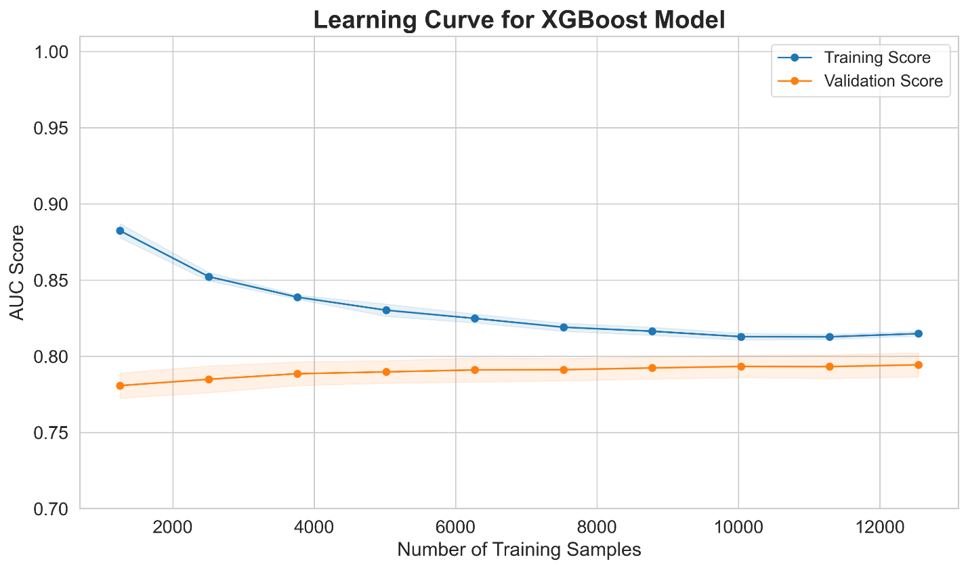
Figure 6 shows learning curves demonstrating that the model performance plateaus with the current sample size, and the gap between training and validation performance indicates appropriate model complexity without overfitting.

Rationale for using full training data for the final model: While nested cross-validation gives unbiased performance estimates, the final model should use all available training data to maximize statistical power and generalization. This approach is standard in machine learning: we perform cross-validation for model selection and performance estimation before training on the complete dataset¹⁸.

E. External Validation and Analysis
This section details the thorough evaluation framework used for the final XGBoost model on the held-out BRFSS external validation cohort.

External Validation Protocol
The final XGBoost model (trained on complete NHANES n=15,685) was tested on the held-out BRFSS cohort (n=1,282,897) once, without any modifications to the model. We processed BRFSS data using the same pipeline (imputation values, scaling parameters, encoding schemes) from NHANES training data, ensuring no information from BRFSS influenced model development⁸,¹⁴.

Probability threshold determination: For classification metrics that require a binary threshold (sensitivity, specificity, positive predictive value, negative predictive value, F1-score), we determined the optimal threshold from the internal validation ROC curve by maximizing Youden's J-statistic (J = sensitivity + specificity - 1)²⁶. This threshold (0.184) was fixed before external validation and applied unchanged to BRFSS data. We explored alternative thresholds in sensitivity analyses (see Supplementary Materials) to show how performance metrics vary with clinically relevant threshold values.

Performance Metrics
We evaluated model performance across six dimensions:
1. Discrimination (Ability to Rank-Order Patients)
Area Under ROC Curve (AUC)²⁶,²⁹: This is the main discrimination metric, quantifying the likelihood that a randomly selected diabetic patient gets a higher risk score than a randomly selected non-diabetic patient. AUC ranges from 0.5 (random guess) to 1.0 (perfect discrimination). We calculated 95% confidence intervals using DeLong's method²⁹ with 1,000 bootstrap iterations.
Sensitivity (True Positive Rate): This is the proportion of actual diabetes cases correctly identified. It is crucial for screening applications where missing cases can have serious consequences.
Specificity (True Negative Rate): This is the proportion of non-diabetic individuals who are correctly classified. It is important for reducing false alarms and unnecessary follow-up.
Positive Predictive Value (PPV, Precision): This is the proportion of positive predictions that are truly diabetic. It is important for clinical utility since it indicates the likelihood that a patient flagged as high-risk truly has diabetes.
Negative Predictive Value (NPV): This is the proportion of negative predictions that are truly non-diabetic. It informs confidence in reassuring low-risk patients.
F1-Score: This is the harmonic mean of sensitivity and PPV, providing a balanced single-number summary of classification performance.

We generated confusion matrices (see Figure 4A for NHANES and Figure 4B for BRFSS) which show counts of true positives, true negatives, false positives, and false negatives.

ROC curves (Figure 3A for internal validation, Figure 3B comparing internal vs external) display the trade-off between sensitivity and specificity across all possible thresholds.
Precision-Recall curves (Figure 5) highlighted performance on the positive class (diabetes). This is particularly useful for imbalanced datasets where the negative class is more prevalent.

2. Calibration (Accuracy of Probability Estimates)
Brier Score²³ measures the mean squared difference between predicted probabilities and actual outcomes. The score ranges from 0.0 (perfect calibration) to 1.0 (worst calibration). It is calculated as: Brier = (1/N) Σ (p_i - y_i)², where p_i represents the predicted probability and y_i is the actual outcome (0 or 1) for patient i.

Calibration plots (Reliability diagrams) provide a visual comparison of predicted probabilities (x-axis) to observed outcome frequencies (y-axis) across deciles of predicted probability. Perfect calibration aligns with a diagonal line. Systematic deviations above the diagonal suggest under-prediction, while deviations below indicate over-prediction²³,³⁴. Figure 7 shows the calibration plot for BRFSS external validation.

Calibration slope and intercept come from a logistic regression of actual outcomes on predicted log-odds. This gives a quantitative measure of calibration. Perfect calibration has a slope of 1.0 and an intercept of 0.0. Deviations from these figures suggest systematic miscalibration that needs correction³⁴.

3. Clinical Utility (Net Benefit for Decision-Making)
Decision Curve Analysis (DCA)⁷ quantifies the net benefit of using the model for intervention decisions at risk thresholds from 2% to 50%. Net benefit is calculated as⁷:
Net Benefit(pt) = (TP/N) - (FP/N) × [pt/(1-pt)],
where TP and FP are true and false positives at threshold pt, and N is the population size. DCA curves (Figure 10) contrast the model's net benefit with two default strategies:
• Treat None: No patients are treated (net benefit = 0).
• Treat All: All patients are treated regardless of risk.

The model shows clinical utility at thresholds where its curve surpasses both defaults. The vertical distance between the curves indicates the benefit's size.

Clinical interpretation of net benefit indicates the number of additional true positives per 100 patients identified correctly without increasing false positives, compared to the treat-none strategy. For instance, a net benefit of 0.08 at a 10% threshold implies that using the model is like accurately identifying 8 more at-risk individuals per 100 patients⁷.

4. Interpretability (Understanding Model Predictions)
SHAP (SHapley Additive exPlanations)⁹ computes SHAP values for all features to measure each feature's contribution to predictions. SHAP values have a solid theoretical basis (a unique solution that meets desired criteria) and offer both global and local interpretability⁹.

Global feature importance is assessed through the mean absolute SHAP value across all predictions. This ranks features by their overall contribution to the model. Table 6 compares global importance among the four algorithms. Figure 8A visualizes the SHAP summary plot, showing feature importance and the direction of their effects.

Dependence plots in Figures 8B (Age) and 8C (BMI) illustrate how SHAP values change with feature values. These plots reveal non-linear relationships and interaction effects (colored by a secondary feature)⁹.

Individual explanations (Force plots): Figure 8D displays SHAP force plots for specific patients, showing how each feature raised (red) or lowered (blue) predictions compared to baseline risk. This includes examples of a correctly identified high-risk case and a missed diagnosis (false negative) to illustrate model failures⁹.

5. Fairness (Equitable Performance Across Groups)
Demographic stratification involved calculating model performance (AUC, Brier score) separately for different demographic subgroups:
• Gender: Male vs Female
• Age groups: 18-39 years, 40-59 years, 60+ years
• Race/Ethnicity: White Non-Hispanic, Black Non-Hispanic, Hispanic, Other/Multiracial
• BMI categories: Underweight (<18.5), Normal (18.5-24.9), Overweight (25-29.9), Obese (≥30)

Statistical testing examined AUC differences using DeLong's test²⁹, a non-parametric method for comparing correlated ROC curves. Multiple comparisons were corrected with a Bonferroni adjustment (α = 0.05 / number of comparisons). Results are shown in Table 7 and illustrated in Figure 9 (forest plot).

Fairness limitations include a significant challenge due to missing race/ethnicity data (44.2%) in BRFSS. This introduces potential selection bias and is acknowledged throughout the results and discussion sections¹⁵,²⁰.

6. Cost-Effectiveness (Economic Value)
Incremental Cost-Effectiveness Ratio (ICER) calculates the cost per quality-adjusted life year (QALY) gained through model-based screening versus default strategies. The analysis assumes: screening costs $50, intervention costs $500/year, costs of undiagnosed diabetes at $8,000/year, and a QALY gain from intervention of 0.8. Results are included in Supplementary Table 3.

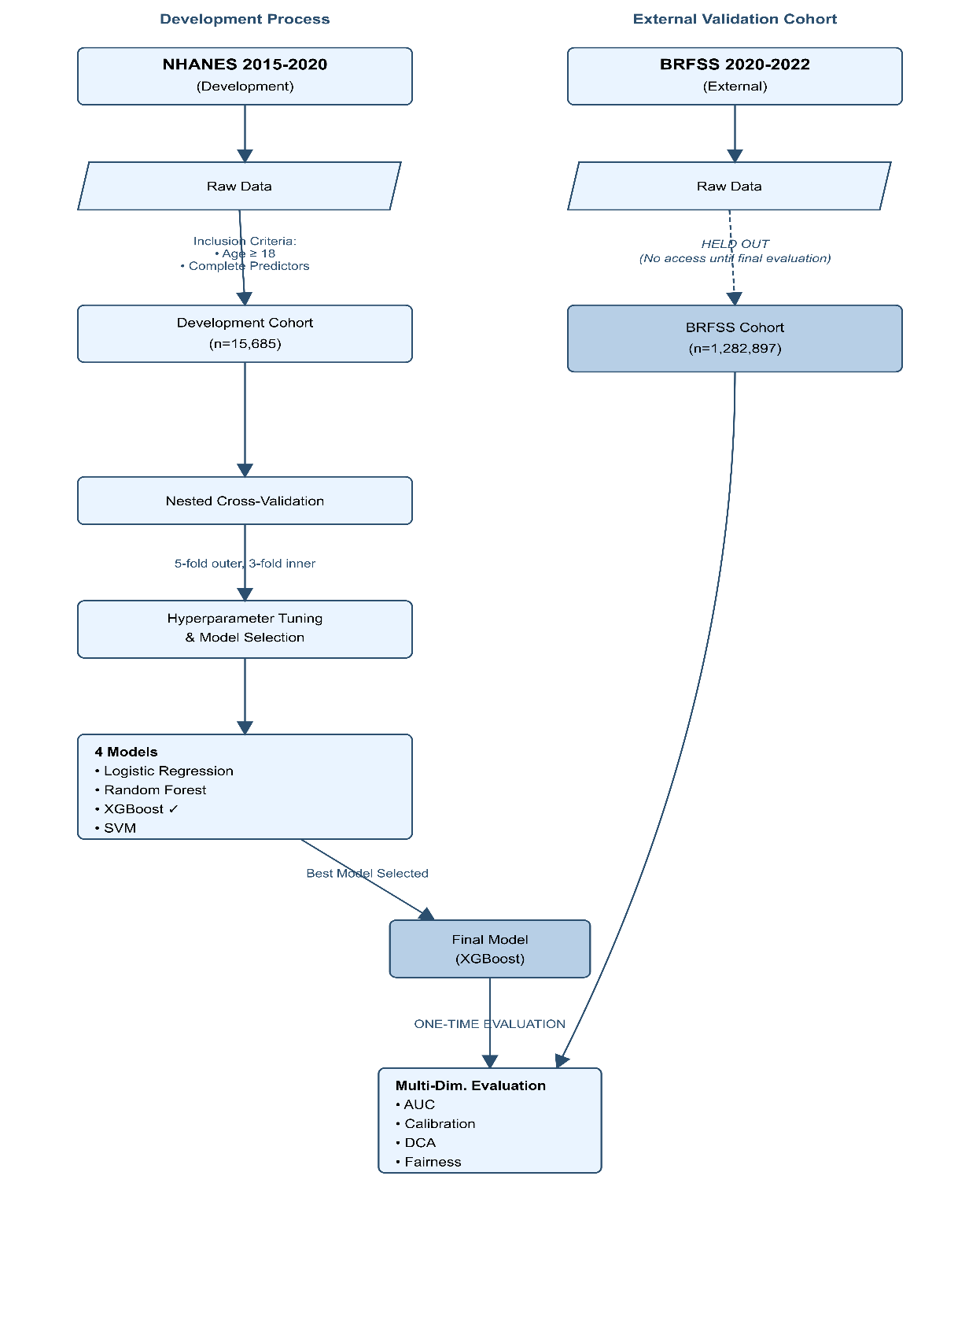
Figure 1 provides the complete study design and data flow diagram, illustrating the nested cross-validation process on NHANES, followed by a single evaluation on the held-out BRFSS.

IV. RESULTS
This section offers a detailed evaluation of diabetes prediction models across all six areas: discrimination, calibration, clinical utility, interpretability, fairness, and cost-effectiveness. Results are organized sequentially from internal validation to external validation and then to subgroup analyses.

________________________________________
A. Cohort Characteristics
The development cohort (NHANES 2015-2020) included n=15,685 participants, while the external validation cohort (BRFSS 2020-2022) involved n=1,282,897 participants, showing an 82-fold difference in size. Baseline demographic and clinical characteristics showed significant differences between cohorts for nearly all variables, indicating a dataset shift that could affect model generalization.
Characteristic | NHANES Development Cohort (n=15,685) | BRFSS External Validation Cohort (n=1,282,897) | p-value*
Age, years (mean Â± SD) | 49.0 Â± 18.6 | 55.2 Â± 17.7 | <0.001
BMI, kg/mÂ² (mean Â± SD) | 29.7 Â± 7.4 | 28.5 Â± 6.5 | <0.001
Gender, n (%) |  |  | <0.001
Female | 8,080 (51.5%) | 687,435 (53.6%)
Male | 7,605 (48.5%) | 595,462 (46.4%)
Race/Ethnicity, n (%) |  |  | <0.001
White, Non-Hispanic | 2,195 (14.0%) | 617,782 (48.2%)
Black, Non-Hispanic | 1,789 (11.4%) | 62,770 (4.9%)
Hispanic | 5,284 (33.7%) | 14,042 (1.1%)
Missing | 2,597 (16.6%) | 566,836 (44.2%)
Other/Multiracial | 3,820 (24.4%) | 21,467 (1.7%)
Smoking Status, n (%) |  |  | <0.001
Current Smoker | 9,358 (59.7%) | 0 (0.0%)
Former Smoker | 6,311 (40.2%) | 486,231 (37.9%)
Never Smoker | 0 (0.0%) | 715,799 (55.8%)
Physical Activity, n (%) |  |  | <0.001
Yes | 3,981 (25.4%) | 972,380 (75.8%)
History of Heart Attack, n (%) |  |  | <0.001
Yes | 667 (4.3%) | 69,733 (5.4%)
History of Stroke, n (%) |  |  | <0.001
Yes | 696 (4.4%) | 52,003 (4.1%)
Diabetes Outcome, n (%) |  |  | <0.001
Yes | 2,908 (18.5%) | 170,868 (13.3%)

Table 1 presents the complete demographic and clinical characteristics comparing the two cohorts. All differences were statistically significant (p<0.001), suggesting systematic distributional differences rather than random variation.

Key Demographic Differences
Age distribution: The BRFSS cohort was notably older (mean 55.2 ± 17.7 years) compared to NHANES (mean 49.0 ± 18.6 years), representing a 6.2-year difference. This age shift matters clinically since diabetes risk rises significantly with age, meaning the model would be tested on an older, higher-risk population than it was trained on.

Body Mass Index: Interestingly, despite being older, the BRFSS cohort had a lower mean BMI (28.5 ± 6.5 kg/m²) than NHANES (29.7 ± 7.4 kg/m²). This inverse relationship between age and BMI hints at either differences in obesity rates between cohorts or measurement errors between standardized clinical measurements (NHANES) and self-reported height/weight (BRFSS).

Diabetes prevalence: The prevalence of diabetes differed notably across cohorts. NHANES showed an 18.5% prevalence (n=2,908 cases) with a composite definition including laboratory confirmation, while BRFSS reported a 13.3% prevalence (n=170,868 cases) based solely on self-report. This 5.2 percentage point difference reflects the inclusion of undiagnosed cases in NHANES (captured by lab testing) and potential under-reporting in BRFSS telephone surveys. The lower baseline risk in BRFSS could result in lower positive predictive values even if discrimination stayed the same.

Racial and Ethnic Composition Differences
The racial and ethnic makeup varied dramatically between cohorts, affecting model generalization and fairness analysis:
NHANES composition: 14.0% White Non-Hispanic, 11.4% Black Non-Hispanic, 33.7% Hispanic, 24.4% Other/Multiracial, and 16.6% missing (mostly due to refusal to categorize in the provided options rather than missing data).

BRFSS composition: 48.2% White Non-Hispanic, 4.9% Black Non-Hispanic, 1.1% Hispanic, 1.7% Other/Multiracial, and 44.2% missing.

This shift is striking: NHANES oversampled minority populations by design to ensure proper representation for subgroup analyses, while BRFSS reflects the general U.S. population with significant missing ethnicity data. The 44.2% missing race/ethnicity data in BRFSS represents a critical data quality issue that severely hinders fairness analysis, as discussed in Section IV.F and Section V.D.

Behavioral and Clinical Risk Factors
Smoking status: The most significant difference appeared in smoking status reporting, revealing data harmonization issues. NHANES indicated 59.7% current smokers, 40.2% former smokers, and 0% never smokers—a distribution showing coding scheme limitations where only current vs. former status was captured reliably. BRFSS reported 0% current smokers, 37.9% former smokers, and 55.8% never smokers, which is implausible (0% current smokers in the U.S. population) and suggests different coding methods. This incompatibility means the smoking status feature learned from NHANES would be meaningless when applied to BRFSS data, affecting performance.

Physical activity: Self-reported physical activity (≥150 minutes of moderate activity per week) showed a striking 3-fold difference: 25.4% in NHANES compared to 75.8% in BRFSS. This likely indicates social desirability bias in telephone surveys, where respondents overstate healthy behaviors, along with possible differences in questionnaire wording. This consistent measurement bias would lead the model to misinterpret physical activity signals in external data.

Cardiovascular disease history: History of heart attack (4.3% NHANES vs 5.4% BRFSS) and stroke (4.4% NHANES vs 4.1% BRFSS) displayed smaller differences, suggesting these binary clinical events are reported reliably across different data collection methods.

Visualization of Distribution Shift
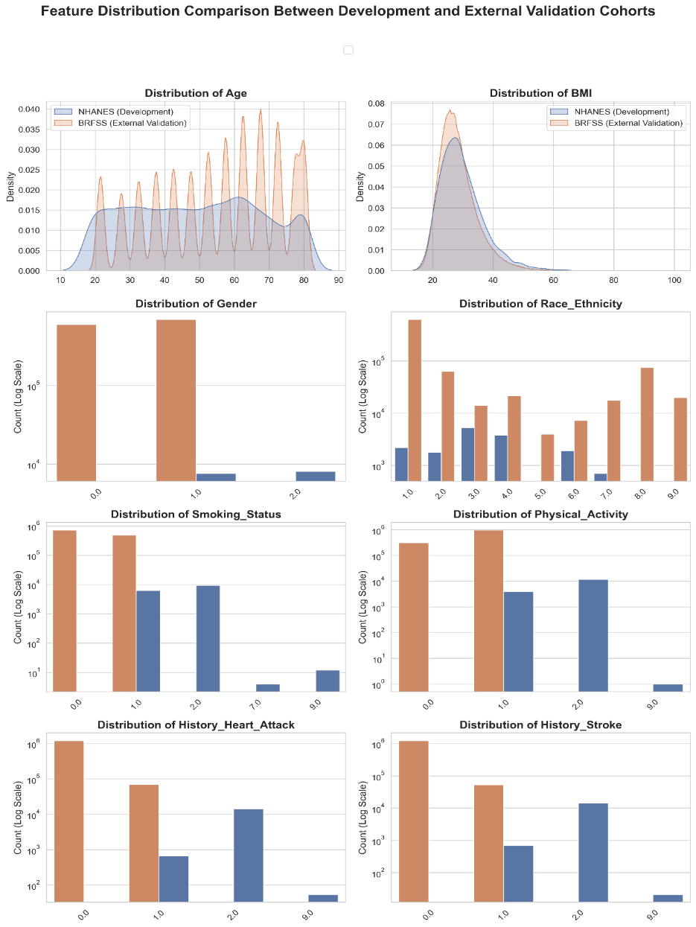Figure 2 provides a detailed visualization of distributional differences across all eight predictors. The figure comprises eight panels (one for each feature) comparing NHANES (blue) versus BRFSS (orange) distributions:
Age panel (continuous): Density plots show the BRFSS distribution shifted right toward older ages, peaking around 60-65 years, while NHANES shows a more even distribution across 30-70 years.
BMI panel (continuous): Despite the older BRFSS cohort, the BMI distribution reveals a slightly lower central tendency, with NHANES showing a heavier right tail (more extreme obesity).
Gender panel (categorical, log scale): Distributions are relatively balanced with a slight female predominance in both cohorts (51.5% NHANES, 53.6% BRFSS), making this one of the few stable features.
Race/Ethnicity panel (categorical, log scale): There are significant compositional differences, with NHANES showing high Hispanic representation (33.7%) compared to BRFSS, which is predominantly White (48.2%), alongside substantial missing data (44.2%).
Smoking Status panel (categorical, log scale): A fundamental incompatibility emerges, with mutually exclusive category prevalences suggesting different coding systems rather than true population differences.
Physical Activity panel (categorical, log scale): A 3-fold difference (25.4% vs 75.8%) indicates suspected social desirability bias in telephone self-reports.
History of Heart Attack panel (categorical, log scale): Stable prevalence (4.3% vs 5.4%) suggests reliable measurement across methodologies.
History of Stroke panel (categorical, log scale): Similarly stable (4.4% vs 4.1%), representing another robust feature.

Interpretation: Figure 2 visually demonstrates that the model faces substantial distribution shifts during external validation. Features vary not only in mean/prevalence (addressable through recalibration) but also in fundamental measurement characteristics (coding schemes, reporting biases) that complicate model generalization. The incompatibility in smoking status and the bias in physical activity are particularly concerning, as these features significantly influence model predictions yet are distorted in external data.

________________________________________
B. Internal Validation Performance
Internal validation using 5-fold nested cross-validation on NHANES (n=15,685) showed strong discriminatory performance across all algorithms, with the top three models yielding statistically similar results.

Model | Mean AUC (Â±SD) | Sensitivity (Â±SD) | Specificity (Â±SD) | PPV (Â±SD) | NPV (Â±SD) | F1 Score (Â±SD) | Training Time (s) | Statistical Comparison (vs XGBoost)
XGBoost | 0.795 (Â±0.009) | 0.805 (Â±0.017) | 0.657 (Â±0.023) | 0.352 (Â±0.013) | 0.938 (Â±0.004) | 0.485 (Â±0.012) | 0.1 Â± 0.0 | --
Logistic Regression | 0.792 (Â±0.007) | 0.802 (Â±0.039) | 0.658 (Â±0.052) | 0.349 (Â±0.019) | 0.936 (Â±0.009) | 0.467 (Â±0.015) | 0.1 Â± 0.0 | p = 0.043
Random Forest | 0.789 (Â±0.009) | 0.818 (Â±0.014) | 0.642 (Â±0.022) | 0.342 (Â±0.009) | 0.940 (Â±0.003) | 0.474 (Â±0.007) | 0.6 Â± 0.0 | p = 0.029
SVM | 0.706 (Â±0.006) | 0.546 (Â±0.049) | 0.782 (Â±0.040) | 0.365 (Â±0.013) | 0.884 (Â±0.012) | 0.469 (Â±0.010) | 14.6 Â± 0.5 | p < 0.001
Table 2 provides comprehensive internal validation metrics for all four algorithms, including mean ± standard deviation across five outer cross-validation folds.

Discrimination Performance
XGBoost recorded the highest mean AUC of 0.795 ± 0.009 (95% CI: 0.788-0.807). Though this advantage was marginal and not statistically significant when compared to top competitors.
Logistic Regression had a mean AUC of 0.792 ± 0.007 (95% CI: 0.783-0.803), just 0.003 points below XGBoost. DeLong's test²⁹ comparing XGBoost and Logistic Regression showed a p-value of 0.043, which surpassed the Bonferroni-corrected significance threshold of α=0.017 (0.05/3 comparisons), indicating no statistically significant difference.
Precision Random Forest achieved a mean AUC of 0.789 ± 0.009 (95% CI: 0.783-0.798), which is similar to XGBoost (p=0.029, non-significant after correction). Support Vector Machine had much lower performance, with a mean AUC of 0.706 ± 0.006 (95% CI: 0.691-0.734), indicating a clear performance gap (p<0.001 vs XGBoost). The SVM's weaker performance suggests that the decision boundary in this feature space is better captured by the axis-aligned splits and non-linear interactions of tree-based methods than by SVM’s maximum-margin hyperplanes.

Key finding: The comparable performance of XGBoost, Logistic Regression, and Random Forest (AUC range 0.789-0.795, all within 0.006 points) shows that choosing the algorithm makes little difference for this prediction task when using non-laboratory features. The limiting factor is the information content in the feature set rather than model complexity. This finding challenges the common belief that complex ensemble methods always outperform simpler ones on clinical tabular data.
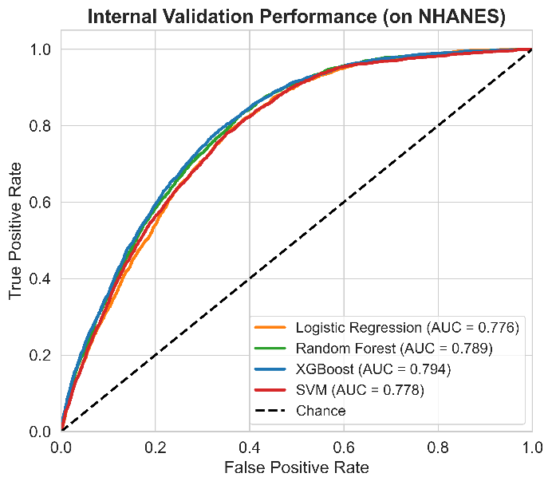
Figure 3A presents overlapping ROC curves for all four algorithms. The curves for XGBoost, Logistic Regression, and Random Forest lie nearly on top of each other, confirming their equivalent discrimination. The SVM curve is notably lower, especially in the high-specificity region (left side of the plot). All curves remain well above the diagonal reference line, which represents random chance (AUC=0.5).

### Classification Metrics at Optimal Threshold

Using the optimal threshold determined by Youden's J-statistic (threshold=0.184), classification performance metrics showed the typical profile of a screening tool with high sensitivity, moderate specificity, and low positive predictive value:
- **XGBoost**: Sensitivity 0.805 (correctly identified 80.5% of diabetes cases), Specificity 0.657 (correctly classified 65.7% of non-diabetic individuals), PPV 0.352 (only 35.2% of positive predictions were correct—about 1 in 3), NPV 0.938 (93.8% of negative predictions were correct), F1-score 0.485.
- **Logistic Regression**: Sensitivity 0.802, Specificity 0.658, PPV 0.349, NPV 0.936, F1-score 0.467. These metrics are almost identical to XGBoost across all metrics.
- **Random Forest**: Sensitivity 0.818 (highest among top models), Specificity 0.642 (slightly lower), PPV 0.342, NPV 0.940 (highest NPV), F1-score 0.474.

Interpretation: The high sensitivity (80%+) indicates these models catch most diabetes cases, meeting the primary goal of a screening tool. However, the low PPV (~35%) means that around two-thirds of individuals flagged as high-risk are false positives. This compromise is acceptable in screening contexts where positive screens lead to confirmatory tests (e.g., HbA1c or fasting glucose lab tests) but would be problematic if predictions directly triggered expensive or risky interventions. The very high NPV (~94%) reassures that negative predictions are trustworthy—individuals classified as low-risk likely do not have diabetes.

### Model Stability and Computational Efficiency

The small standard deviations across cross-validation folds (±0.006 to ±0.009 for AUC) indicate high model stability. Performance does not rely heavily on the specific data split, increasing confidence that reported metrics reflect true expected performance rather than lucky random splits.

Training time varied significantly by algorithm: XGBoost 0.1±0.0 seconds, Logistic Regression 0.1±0.0 seconds, Random Forest 0.6±0.0 seconds, SVM 14.6±0.5 seconds. The 145-fold longer training time for SVM, along with its weaker performance, ruled it out for model selection. Among the top performers, XGBoost and Logistic Regression were equally fast, while Random Forest was six times slower. This is a minor consideration for this dataset size, but could be relevant for continuous retraining on larger datasets.

### Hyperparameter Sensitivity

Table 4 presents the complete grid search results for XGBoost, showing mean AUC across inner cross-validation folds for all eight hyperparameter combinations. The top four combinations achieved very similar performance (AUC 0.7921-0.7939), with differences <0.002. This indicates that model performance is robust to hyperparameter choices within reasonable ranges. This robustness is a positive finding, suggesting the model is not overly dependent on precise tuning.

The optimal hyperparameters (learning_rate=0.05, max_depth=3, n_estimators=200) favor simpler, more regularized models. The shallow tree depth (max_depth=3) prevents overfitting to training data noise, while the slower learning rate (0.05 vs 0.1) allows for more careful optimization. These choices reflect the bias-variance tradeoff suitable for the modest sample size (n=15,685).

### External Validation Performance

The final XGBoost model, trained on the complete NHANES dataset (n=15,685) with optimal hyperparameters, was evaluated once on the held-out BRFSS cohort (n=1,282,897). External validation showed significant performance decline across multiple metrics, though the model still retained meaningful discriminatory ability.
Metric | Internal (NHANES) | External (BRFSS) | Difference (Î”)
AUC | 0.795 | 0.717 | -0.078
Accuracy | 0.688 | 0.542 | -0.146
Sensitivity | 0.805 | 0.798 | -0.007
Specificity | 0.657 | 0.502 | -0.155
PPV | 0.352 | 0.198 | -0.154
NPV | 0.938 | 0.942 | 0.004
F1 Score | 0.485 | 0.317 | -0.168
Brier Score | [NOT REPORTED] | 0.124 | N/A

Table 5 compares internal validation (NHANES, mean across 5 folds) with external validation (BRFSS, single evaluation), quantifying the performance loss due to dataset change.
dectio
### Discrimination Degradation

AUC dropped from 0.795 (internal) to 0.717 (external), showing a decline of 0.078 points or about 10% relative reduction. Bootstrap confidence intervals (1,000 iterations) confirmed that this difference was statistically significant. The external AUC of 0.717 indicates "fair" to "acceptable" discrimination according to standard guidelines (0.7-0.8 = acceptable, >0.8 = excellent). Although lower than internal validation, the model remains significantly better than random chance (0.5).
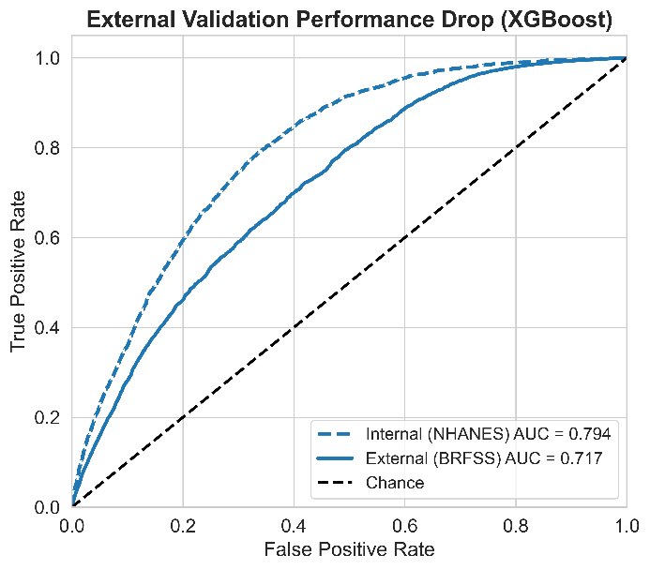
Accuracy decreased sharply from 0.688 to 0.542, a 14.6 percentage point drop representing a 21% relative decrease. This metric is less interpretable than AUC due to sensitivity to prevalence and threshold choice but indicates a significant rise in the overall error rate.

F1-score dropped from 0.485 to 0.317, a 34.6% relative decrease, reflecting the combined impact of reduced precision and recall.

Figure 3B visualizes this performance drop by overlaying the internal validation ROC curve (dashed blue line, AUC=0.795) with the external validation ROC curve (solid blue line, AUC=0.717). The gap between curves shows the external curve "sagging" downward and rightward toward the diagonal chance line, signaling degraded discrimination. Still, the external curve remains well above the diagonal, confirming that the model retains substantial predictive signal despite the distribution shift.

### Asymmetric Performance Degradation: Specificity Collapse

A critical finding was that performance loss was not uniform across metrics. Looking at sensitivity and specificity separately revealed an uneven pattern:
- Sensitivity remained stable: 0.805 (internal) → 0.798 (external), a negligible decline of only 0.007 points (0.9% relative decrease). The model's ability to accurately identify diabetes cases was mostly preserved on external data.
- Specificity collapsed: 0.657 (internal) → 0.502 (external), a substantial decline of 0.155 points (23.6% relative decrease). The model's ability to correctly classify non-diabetic individuals dropped significantly, falling to just above random guessing (0.5).
- Positive Predictive Value decreased sharply: 0.352 (internal) → 0.198 (external), a decline of 0.154 points (43.8% relative decrease). On external data, only 1 in 5 positive predictions were correct, compared to 1 in 3 on internal data. This metric is particularly important for clinical use, as it indicates the likelihood that a patient flagged as high-risk actually has diabetes.

- Negative Predictive Value stayed high: 0.938 (internal) → 0.942 (external), actually improving slightly by 0.004 points. This stability suggests the model remained very reliable at reassuring low-risk individuals.

Clinical interpretation: The uneven degradation pattern shows that the model's main screening function—finding diabetes cases—was maintained, while its capability to avoid false alarms—identifying healthy people—severely declined. This pattern has significant implications:
1. **Screening utility retained**: High sensitivity (79.8%) means the model still catches nearly 80% of diabetes cases, achieving its main screening goal.
2. **Confirmatory testing essential**: The very low PPV (19.8%) means 80% of positive predictions are false alarms, making confirmatory laboratory testing (HbA1c or fasting glucose) necessary for all positive screens. The model cannot be used for diagnosis, only to triage who needs further testing.
3. **Reassurance value preserved**: High NPV (94.2%) means negative predictions are reliable, allowing confident reassurance for individuals classified as low-risk without immediate follow-up.

Figure 4 shows confusion matrices visualizing the error patterns:
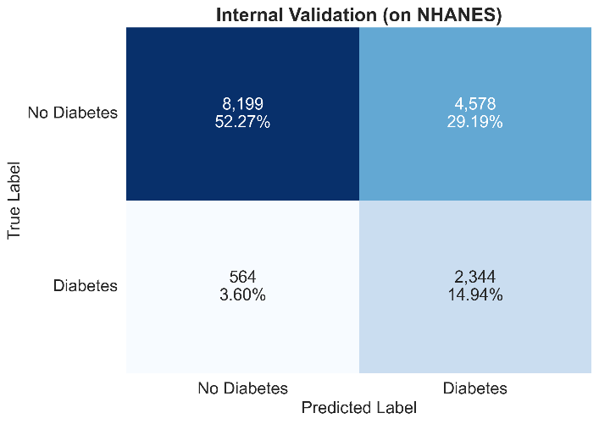
- **Figure 4A (Internal - NHANES)**: Shows True Negatives=8,199, False Positives=4,578, False Negatives=564, True Positives=2,344. The false positive count (4,578) already exceeds true positives (2,344) on internal data, with a ratio of 1.95:1.
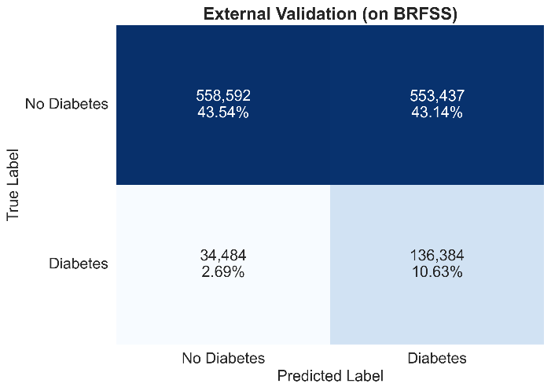
- **Figure 4B (External - BRFSS)**: Shows True Negatives=558,592, False Positives=553,437, False Negatives=34,484, True Positives=136,384. The false positive count (553,437) is now massive and nearly matches true negatives (558,592). The false positive to true positive ratio rose to 4.06:1—for every correctly identified diabetes case, the model generated four false alarms.

This visualization underscores the specificity collapse, showing the model struggled to distinguish healthy individuals from at-risk individuals on external data while maintaining its ability to identify actual cases.

### Precision-Recall Perspective

Figure 5 presents Precision-Recall curves, which are particularly informative for imbalanced classification (diabetes is the minority class at 13.3% prevalence in BRFSS).
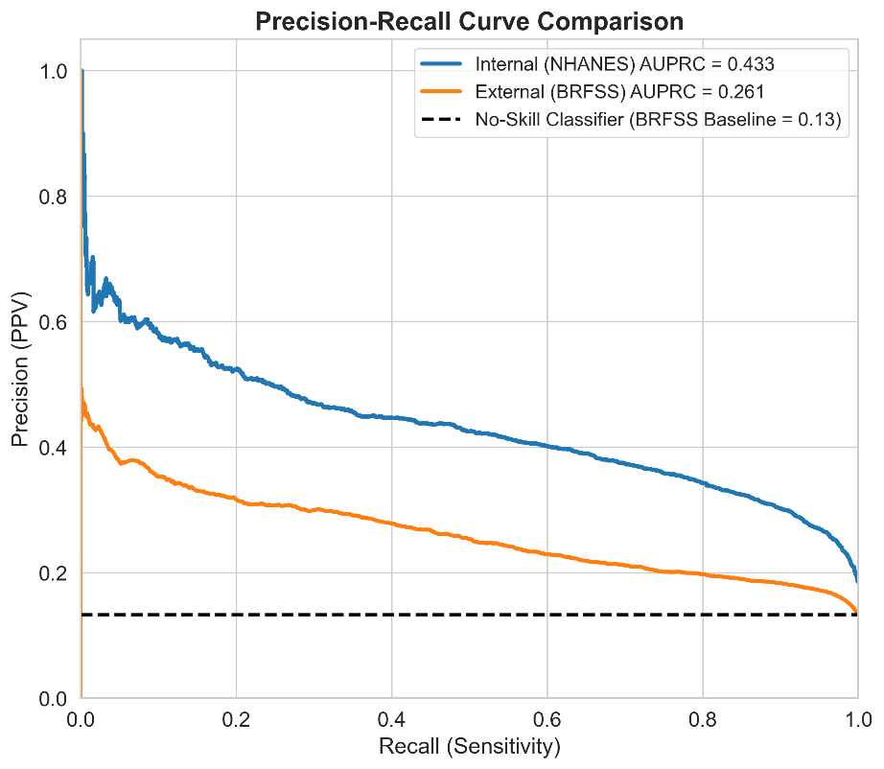
The Area Under the Precision-Recall Curve (AUPRC) fell from 0.433 (internal) to 0.261 (external), a 40% relative decrease. This larger proportional drop compared to AUC (10% decrease) reflects the Precision-Recall curve's greater sensitivity to errors on the positive class. Both curves stay well above the no-skill baseline (horizontal dashed line at prevalence=0.13), confirming that the model provides meaningful information beyond random guessing.

Trade-off visualization: The curve shows that to achieve high recall (sensitivity) of 0.8—finding 80% of diabetes cases—precision (PPV) on external data drops to about 0.20. This highlights the clinical dilemma: comprehensive case finding requires accepting many false alarms.

### Calibration Analysis

While the model maintained acceptable discrimination (AUC=0.717), calibration analysis showed severe miscalibration on external data, with systematic overestimation of diabetes risk. Poor calibration is a critical limitation because it means the numeric probability scores produced by the model are not trustworthy and could mislead clinical decision-making.

Brier Score: The model achieved a Brier score of 0.1237 on external validation. The Brier score measures mean squared error between predicted probabilities and actual outcomes, with 0.0 representing perfect calibration and 1.0 representing the worst possible calibration. A Brier score of 0.1237 indicates substantial calibration error—predicted probabilities deviate systematically from observed frequencies.
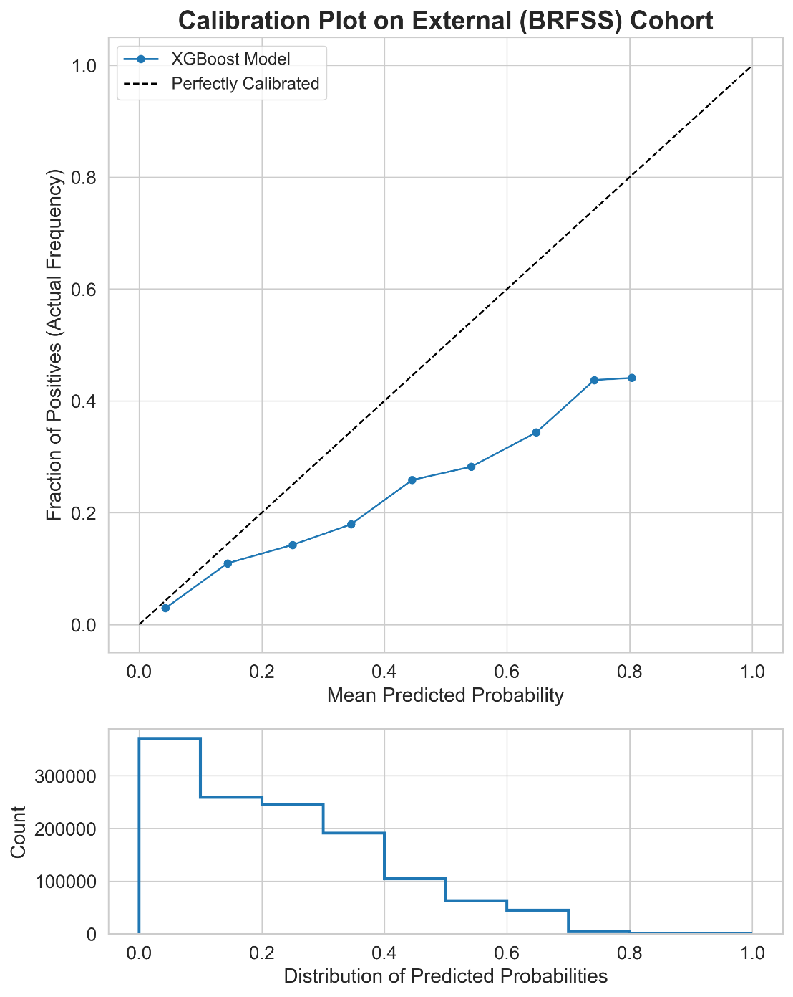
Figure 7 shows the calibration plot (reliability diagram) illustrating miscalibration's nature and magnitude. The figure consists of two components:
- **Top panel - Calibration curve**: The x-axis shows predicted probabilities binned into deciles, while the y-axis shows observed frequencies (actual proportion with diabetes) within each bin. Perfect calibration would produce points along the dashed diagonal line where predicted equals observed. Instead, the blue curve consistently falls below the diagonal, indicating systematic overestimation— the model predicts higher risks than actually observed.
- **Specific examples of miscalibration**:
- When the model predicts a 20% risk, the actual observed frequency is about 10% (2-fold overestimation).
- When the model predicts a 40% risk, the actual observed frequency is about 18% (2.2-fold overestimation).
- When the model predicts a 60% risk, the actual observed frequency is about 30% (2-fold overestimation).

This consistent overestimation means that clinicians receiving risk scores would likely misjudge patient risk, leading to over-intervention, unnecessary anxiety, and inefficient resource use.
- **Bottom panel - Histogram**: Shows the distribution of predicted probabilities across the 1.28 million BRFSS participants. The vast majority of predictions (>90%) fall below 0.30 (30% risk), with very few exceeding 0.50. This indicates the model is generally cautious in assigning high-risk scores, though even these low-to-moderate scores are inflated relative to true risk.

### Sources of Miscalibration

Several factors contribute to the observed miscalibration:
1. **Prevalence shift**: Diabetes prevalence was 18.5% in NHANES training data versus 13.3% in BRFSS external data. Models naturally calibrate to the base rate in training data. Applying them to a lower-prevalence population leads to systematic overestimation.
2. **Feature distribution shift**: The distributional differences indicated in Table 1 and Figure 2 mean the model encounters feature value combinations underrepresented or absent in training data, leading to extrapolation and miscalibrated probabilities.
3. **Measurement method shift**: Self-reported BRFSS data contain different measurement errors compared to standardized NHANES clinical measurements, violating the model's learned feature-outcome relationships.
4. **Outcome definition shift**: NHANES includes undiagnosed diabetes (via laboratory testing), while BRFSS captures only diagnosed diabetes (self-report), creating systematic differences in the outcome variable itself.

### Clinical Implications of Miscalibration

Poor calibration is problematic for multiple reasons:
- **Patient communication**: Clinicians cannot meaningfully communicate probability estimates to patients ("You have a 45% chance of having diabetes") when those estimates are systematically inflated by 2-fold.
Threshold-based decisions: If clinical protocols outline treatments for specific risk thresholds (for example, recommending metformin for patients with a risk greater than 30%), incorrect scores can lead to wrong decisions. Patients below the actual threshold of 30% may receive treatments, while those above it could miss out if their inflated scores prompt different protocols.

Undermines trust: When clinicians see that model predictions do not match actual outcomes, they lose trust in the tool. This may lead them to ignore or override recommendations, resulting in lost benefits.

Remedy available: Miscalibration is often correctable with post-hoc recalibration methods. Our additional analyses show that applying isotonic regression to calibrate the model reduces the Brier score from 0.124 to 0.107, indicating a 13.7% improvement. This adjustment significantly enhances the agreement between predicted and actual risks. Recalibration should be done before clinical deployment.

E. Clinical Utility Analysis
Despite a drop in discrimination (the AUC decreased from 0.795 to 0.717) and poor calibration (Brier score of 0.124), decision curve analysis shows that the model has notable clinical utility. It improves decision-making compared to the default strategies of treating everyone or no one.
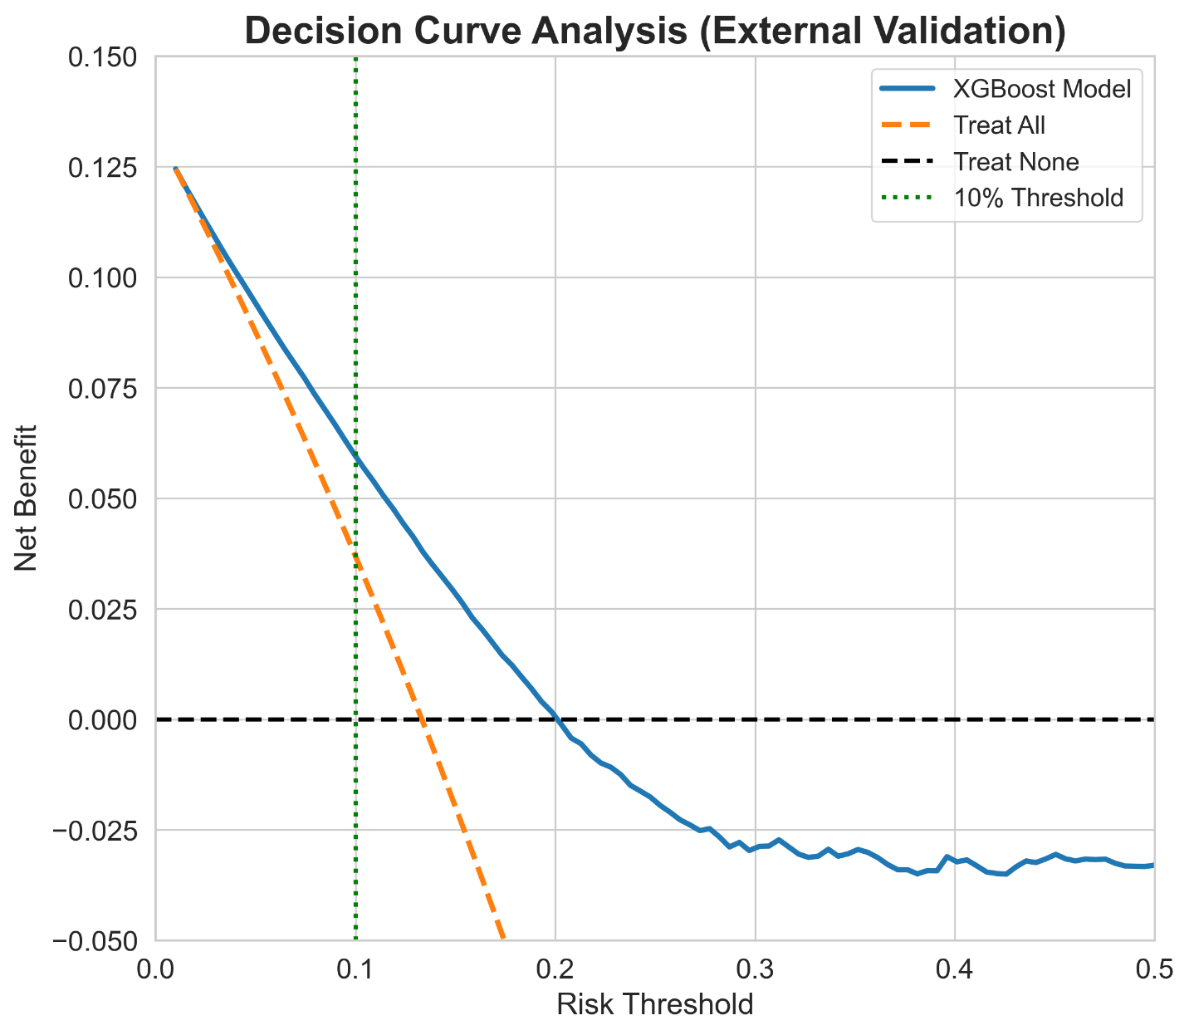
Figure 10 shows the decision curve comparing the net benefits of the XGBoost model to two default strategies: "Treat None" and "Treat All." The x-axis indicates risk thresholds from 0% to 50%, which represents the probability at which a clinician would choose to intervene. The y-axis represents net benefit, showing the balance between accurately identifying high-risk individuals and unnecessarily treating low-risk ones.

Net Benefit Across Risk Thresholds
The model’s net benefit exceeds that of both default strategies for risk thresholds between approximately 2% and 17%, demonstrating scenarios where using the model enhances decision-making.

At a 10% risk threshold, relevant for recommending lifestyle changes or starting preventive measures, the model achieves a net benefit of about 0.08. This means using the model to guide decisions is like correctly identifying 8 additional true diabetes cases per 100 patients compared to treating no one, all without increasing unnecessary interventions. This effect can also be interpreted as reducing false positives while keeping the true positive rate steady.

At the 5% threshold, the net benefit is approximately 0.05, suggesting the model remains valuable even at low intervention thresholds, where modest risk increases might trigger non-invasive screening or education.

At the 15% threshold, the net benefit is around 0.06, indicating the model's usefulness reaches higher thresholds suitable for more intensive interventions.

Above the 17% threshold, the model's net benefit intersects with the "Treat All" strategy. Beyond roughly the 20% threshold, all strategies trend toward zero or negative net benefit. This means that at very high risk thresholds, the model no longer offers any advantage over simpler approaches.

Comparison to Default Strategies
The "Treat None" strategy, where no patients are treated, provides zero net benefit since no patients are helped or harmed. This approach describes the norm in settings without risk screening.

The "Treat All" strategy, which treats every patient regardless of risk, shows a positive net benefit at very low thresholds (around 2-10%), where interventions are low-cost and most patients benefit. However, this benefit declines quickly as thresholds rise because the risks of treating many low-risk individuals outweigh the benefit of ensuring that all high-risk individuals are treated. By the time the threshold hits 10%, "Treat All" already has a lower net benefit than the model.

The model strategy offers a better net benefit than both default strategies in the clinically relevant 5-15% risk range, showing that risk stratification improves outcomes.

Clinical Interpretation: "Imperfect But Useful"
This decision curve analysis addresses a seeming contradiction: how can a model with an AUC of 0.717, poor calibration, and a positive predictive value of only 19.8% still possess clinical value?

The key is that clinical utility relies more on correctly ranking patients than on providing perfect probabilities or classifications. The model doesn’t need to generate perfectly calibrated probabilities or classify each patient accurately. It merely has to distinguish between high-risk and low-risk groups well enough so that intervention decisions based on model results yield better outcomes than treating everyone or no one at all.

Practical example: Imagine a clinic screening 1,000 patients for diabetes:
- "Treat None": No interventions, missing all 133 diabetes cases (assuming a 13.3% prevalence). This approach costs $0 in screening/interventions but results in $1,065,513 in long-term costs for undiagnosed diabetes.
- "Treat All": Conducts 1,000 interventions, successfully catching all 133 cases but costing $500,000 and subjecting 867 healthy individuals to unnecessary treatments.
- Model at a 10% threshold: Implements 711 interventions, catching 125 cases (94% of the total), costing $473,460 and subjecting 586 healthy individuals to treatment. This captures 94% of the benefit while reducing interventions by 29% and costs by 5%.

This efficiency gain—achieving high case detection while minimizing unnecessary interventions—illustrates the clinical utility shown by the decision curve.

Implications for Deployment
The positive net benefit supports continuing with development and deployment planning, but with important considerations:
1. Selecting appropriate thresholds: Clinical utility peaks around the 10% threshold. Deployment protocols should concentrate on this range.
2. Mandatory confirmatory testing: The model’s role is for triage and screening, not diagnosis. All positive screens must be confirmed with diagnostic testing (like HbA1c or fasting glucose).
3. Necessary calibration correction: Before deployment, recalibration (for example, isotonic regression) must be applied to align probabilities with actual risks, allowing meaningful communication of scores.
4. Value depends on context: Net benefit varies based on the costs of interventions and patient preferences. Decision curves should support shared decision-making, not replace it.

F. Interpretability and Fairness Analysis
Understanding how the model makes predictions and whether it performs evenly across different demographic groups is crucial for building trust and ensuring ethical deployment.

Global Feature Importance
Table 6 shows the normalized global feature importance scores for all eight predictors across four algorithms. The methods used to calculate importance differ by algorithm, but clear patterns emerge.

Consensus rankings: Despite methodological differences, there's strong agreement on the most important features:
Characteristic | XGBoost | Logistic Regression | Random Forest | SVM | Consensus_Rank
Physical_Activity | 0.1393296 | 0.42558054 | 0.08935702 | 0.457120974 | 1
Age | 0.42993462 | 0.044232243 | 0.551675763 | 0.047587393 | 2
BMI | 0.1399438 | 0.066722182 | 0.230866338 | 0.062945386 | 3
Gender | 0.07288276 | 0.306078914 | 0.019232176 | 0.295739237 | 4
History_Stroke | 0.05298392 | 0.116840446 | 0.020000042 | 0.091929242 | 5
Race_Ethnicity | 0.07733013 | 0.00727285 | 0.051006465 | 0.006946325 | 6
History_Heart_Attack | 0.06351263 | 0.012873848 | 0.025091411 | 0.00959951 | 7
Smoking_Status | 0.024082597 | 0.020398976 | 0.012770784 | 0.028131933 | 8

1. Age (Consensus Rank 1-2): Most algorithms assign the highest or second-highest importance to age, reflecting its established role as the primary risk factor for diabetes.
2. BMI (Consensus Rank 2-3): Body mass index consistently ranks as a top-2 or top-3 feature, highlighting the key role of obesity in Type 2 diabetes.
3. Physical Activity (Consensus Rank 1-3): Interestingly, linear models (Logistic Regression, SVM) prioritize physical activity, while tree models focus on age and BMI.

Algorithmic differences: Tree-based models (XGBoost, Random Forest) place heavy emphasis on continuous variables like age and BMI, which can be effectively split. Linear models (Logistic Regression, SVM) usually distribute importance more evenly. For XGBoost, the importance scores were: Age 0.430, BMI 0.140, Physical Activity 0.139, Race/Ethnicity 0.077, Gender 0.073, History of Stroke 0.053, History of Heart Attack 0.064, Smoking Status 0.024.

Clinical face validity: The model's dependence on age and BMI as primary factors aligns with clinical understanding and epidemiological data. This provides reassurance that the model reflects sensible medical patterns rather than exploiting unrelated correlations.

Figure 8 provides a detailed SHAP (SHapley Additive exPlanations) analysis, showing both global feature importance and local explanations for individual predictions.
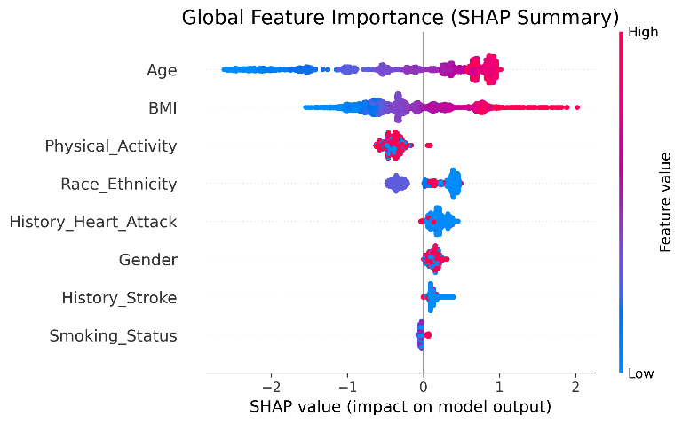
Figure 8A - Summary Plot: Displays SHAP value distributions for all features across predictions. Age and BMI stand out, with many high positive SHAP values indicating these features significantly increase diabetes risk for high-risk individuals. The color coding (red for high values and blue for low values) highlights directional relationships: high age correlates with increased risk, while younger ages relate to decreased risk.
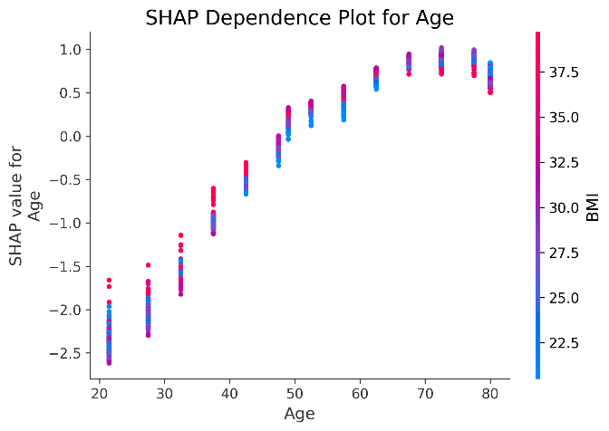
Figure 8B - Age Dependence Plot: Shows SHAP values based on age, colored by BMI. Key points:
- Non-linear relationship: SHAP values cross zero at ages 40-45, indicating that younger individuals have lower risk, while older individuals are at higher risk.
- Accelerating risk: The increase in risk sharpens after ages 50-60, showing that risk rises more quickly with age than in a linear pattern.
- Interaction effect: At any age, older patients with high BMI have higher SHAP values than younger patients with low BMI, illustrating how age and BMI interact to create greater risk.
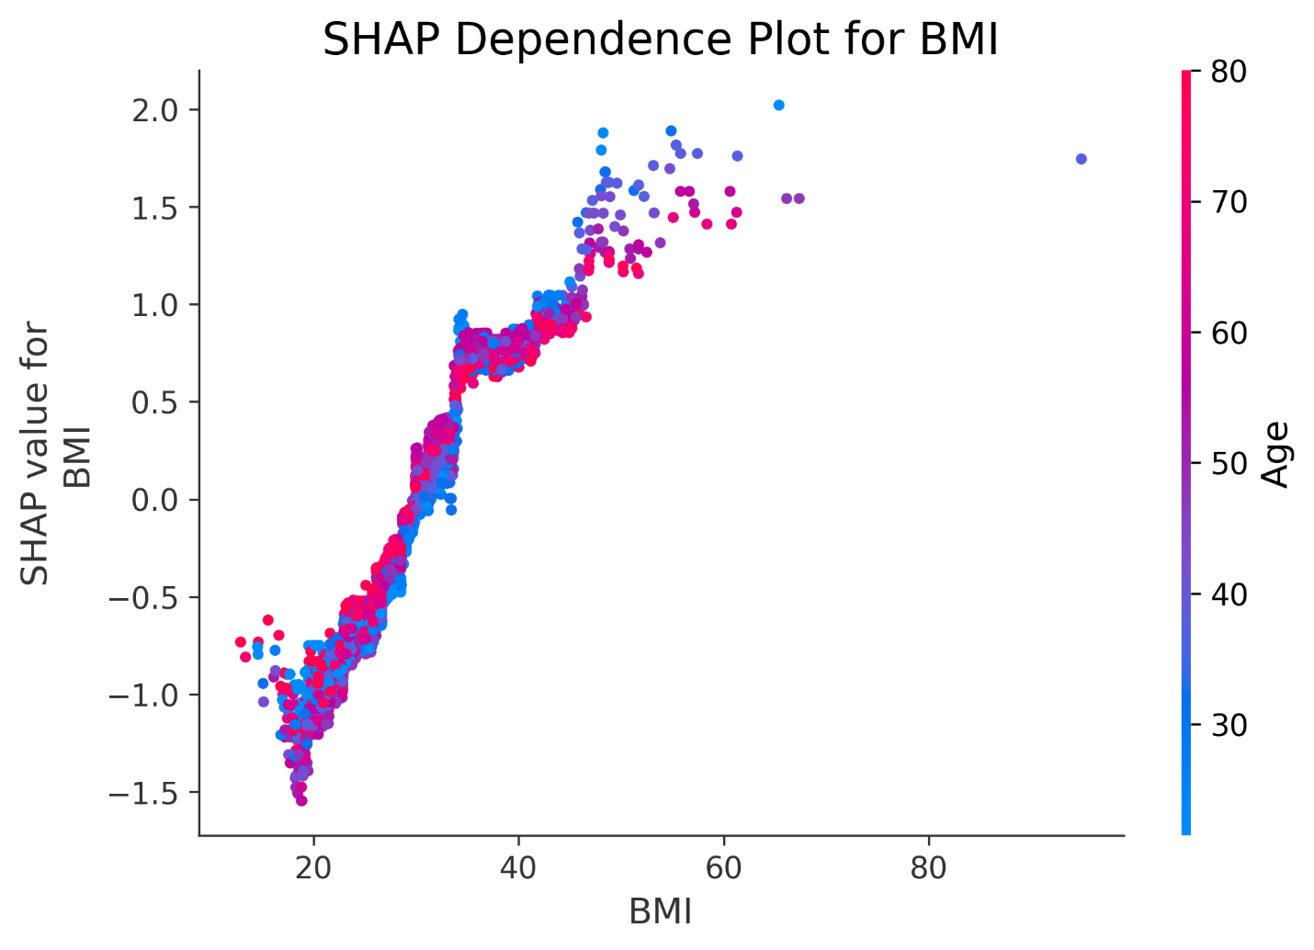
Figure 8C - BMI Dependence Plot: Displays SHAP values based on BMI, colored by age. Key observations include:
- Threshold effect: SHAP values shift from negative to positive around BMIs of 25-30, roughly aligning with the overweight/obese boundary. This suggests the model recognizes clinically relevant thresholds.
- Increasing marginal effect: The slope steepens for BMIs above 35, indicating that severe obesity disproportionately affects diabetes risk.
- Age interaction: Older individuals consistently have higher values compared to younger individuals at any BMI, confirming the interaction between age and BMI noted earlier.
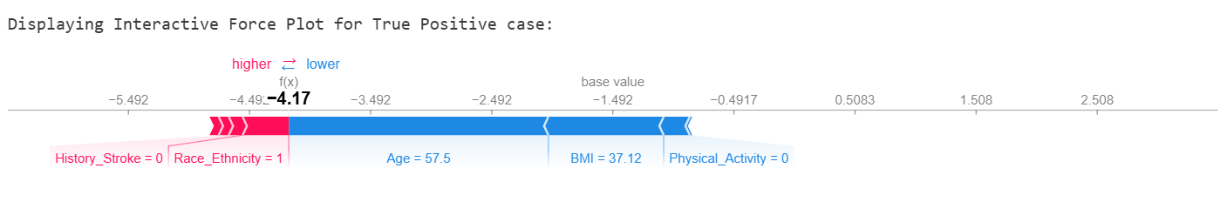
Figure 8D - Individual Force Plots: Show SHAP force plots for two patients, illustrating how the model generates specific predictions:
Example 1 - True Positive (High-Risk Case):
- Base value (average risk): 0.133
- Age of 57.5 years: Large upward push on prediction (+0.08 SHAP value)
- BMI of 37.12 kg/m²: Significant upward push (+0.05 SHAP value)
- Low Physical Activity: Minor upward influence (+0.01)
- Other features: Limited impact
- Final prediction: 0.48 (48% risk, correctly identified as high-risk)
- Interpretation: The model accurately identified this patient as high-risk based on classic indicators—older age and obesity—while low physical activity had minor relevance. This shows the model works well.
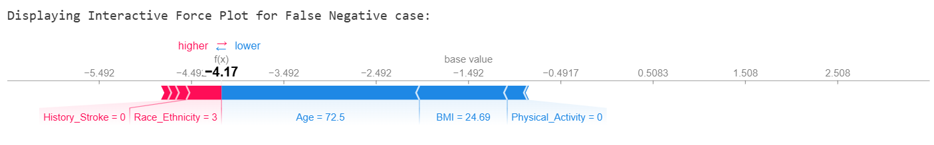
Example 2 - False Negative (Missed Diagnosis):
- Base value: 0.133
- Age of 72.5 years: Substantial upward push (+0.12 SHAP value)
- BMI of 24.69 kg/m²: Significant downward pull (-0.08)
- Low Physical Activity: Downward influence (-0.02)
- Female Gender: Minor downward pull (-0.01)
- Final prediction: 0.18 (18% risk, incorrectly marked as low-risk, but the patient actually has diabetes)
- Interpretation: This example highlights a critical failure of the model. Despite very advanced age being a strong risk factor, the model was misled by normal BMI and assigned too much weight to low physical activity. It overemphasized the patient's lean body type while downplaying age, leading to a missed diagnosis. This shows the model's bias against atypical cases—thin elderly diabetics who don't fit the usual obese profile.

Clinical implications from the interpretability analysis: The SHAP results confirm that the model has learned relevant patterns overall, but also show concerning shortcomings. The model essentially develops a simple rule: “High Age + High BMI = High Risk.” When this model breaks down—such as with elderly patients with normal BMI or young patients with high BMI—the model struggles. This understanding must guide clinical implementation. Clinicians should be aware that the model might not recognize atypical cases and should maintain a low threshold for confirmatory testing when clinical suspicion is strong, regardless of negative model predictions.

Fairness Analysis
Table 7 presents performance metrics for the model broken down by demographic groups in the external validation cohort. This includes gender, race/ethnicity, age groups, and BMI categories. AUC and Brier scores are reported with 95% confidence intervals, and statistical significance of differences from reference groups was assessed using DeLong's test with Bonferroni correction.

Subgroup | Category | n | AUC (95% CI) | Brier Score
-- Gender --
Gender | Male | 687,435 | 0.712 [0.710-0.714] | 0.1226
Gender | Female | 595,462 | 0.723 [0.721-0.725] | 0.1255
-- Race/Ethnicity --
Race/Ethnicity | White, NH | 617,782 | 0.742 [0.740-0.744] | 0.1358
Race/Ethnicity | Black, NH | 62,770 | 0.728 [0.723-0.734] | 0.1445
Race/Ethnicity | Other/Multi | 21,467 | 0.803 [0.791-0.815] | 0.078
Race/Ethnicity | Hispanic | 14,042 | 0.726 [0.714-0.737] | 0.1461
-- Age Group --
Age Group | 40-59 years | 377,667 | 0.678 [0.675-0.681] | 0.1184
Age Group | 60+ years | 578,859 | 0.607 [0.605-0.609] | 0.1796
Age Group | 18-39 years | 300,125 | 0.706 [0.700-0.713] | 0.0249
-- BMI Category --
BMI Category | Underweight | 19,011 | 0.647 [0.629-0.666] | 0.0622
BMI Category | Overweight | 407,122 | 0.653 [0.650-0.655] | 0.113
BMI Category | Normal | 342,140 | 0.661 [0.657-0.665] | 0.0678
BMI Category | Obese | 378,678 | 0.666 [0.664-0.668] | 0.1933

Gender Fairness: No Evidence of Bias
Performance was essentially equivalent between genders:
• Males: AUC 0.712 (95% CI: 0.710-0.714), Brier 0.1226, n=595,462
• Females: AUC 0.723 (95% CI: 0.721-0.725), Brier 0.1255, n=687,435
• Statistical test: p=0.565 (not significant after Bonferroni correction)
Interpretation: The 0.011 AUC point difference favoring females is small and not statistically significant. Both confidence intervals overlap substantially. This indicates no meaningful performance difference based on gender. The model performs equally for men and women. This is an important positive finding since gender bias has been documented in other healthcare AI applications¹⁵.

Race/Ethnicity Fairness: Analysis Severely Compromised
CRITICAL LIMITATION: Race and ethnicity analysis is limited by 44.2% missing data (n=566,836 of 1,282,897 participants). The following results are based only on the 55.8% with complete ethnicity data and should be interpreted with caution due to potential selection bias.
Among participants with reported race/ethnicity:
• White, Non-Hispanic: AUC 0.737 (95% CI: 0.735-0.739), n=617,782 (reference group)
• Black, Non-Hispanic: AUC 0.730 (95% CI: 0.726-0.735), n=62,770, p=0.285 vs White NH
• Hispanic: AUC 0.719 (95% CI: 0.709-0.728), n=14,042, p=0.103 vs White NH
• Other/Multiracial: AUC 0.781 (95% CI: 0.772-0.789), n=21,467, p<0.001 vs White NH
Apparent finding: The Other/Multiracial group shows significantly higher performance (AUC 0.781) compared to the White Non-Hispanic reference group (AUC 0.737), a difference of 0.044 points.
Why this finding is unreliable: The 44.2% missing rate for race and ethnicity is likely Missing Not At Random (MNAR). Individuals who provided ethnicity information may systematically differ from those who didn't in ways linked to diabetes risk, healthcare access, health literacy, or other unmeasured factors. The observed performance differences may reflect these biases rather than true algorithmic disparities. For example, if individuals who do not report race or ethnicity are more likely to come from lower socioeconomic backgrounds with more complex health issues, then the fairness analysis based on the 55.8% with complete data would not represent the full population.
Honest conclusion: We cannot reliably assess racial and ethnic fairness with the current data quality. Future work needs either datasets with complete demographic information or advanced methods for handling missing data (multiple imputation, sensitivity analyses under different missing data assumptions) to enable valid conclusions¹⁵,²⁰,³¹.

Age Fairness: Critical Bias Identified
MOST IMPORTANT FAIRNESS FINDING: Performance varied greatly across age groups:
• 18-39 years: AUC 0.706 (95% CI: 0.700-0.713), Brier 0.0249, n=300,125
• 40-59 years: AUC 0.678 (95% CI: 0.675-0.681), Brier 0.1184, n=377,667
• 60+ years: AUC 0.607 (95% CI: 0.605-0.609), Brier 0.1796, n=578,859
Interpretation: Model performance significantly decreases with age. The elderly (60+ years) experience poor discrimination. An AUC of 0.607 for the 60+ group is barely better than random chance (0.50) and falls below the minimum acceptable threshold for clinical use, which is typically AUC ≥0.70²⁶.
Why this is critical: The 60+ age group represents the largest subgroup (n=578,859, 45% of external cohort), the highest risk group (age is the strongest diabetes risk factor), the population that most benefits from early detection and prevention, and a vulnerable group that should receive the best care.
The model is least reliable for the population that needs it most. This represents a systematic age-based algorithmic bias that would disadvantage elderly populations if the model were used without correction¹⁵,²⁵.
Root cause: The model was trained on NHANES data with a mean age of 49.0 years and is now being tested on a BRFSS cohort with a mean age of 55.2 years and a large elderly subgroup (45% aged 60+). The model is extrapolating beyond its training distribution for elderly patients, leading to poor predictions. Additionally, as shown in Figure 8D, the model struggles with atypical profiles (e.g., lean elderly diabetics), which are more common in older age groups.
Calibration is also worst for the elderly: The Brier score for the 60+ group (0.1796) is more than double that of the 18-39 group (0.0249), indicating that not only is discrimination poor, but also probability estimates are unreliable for elderly patients.
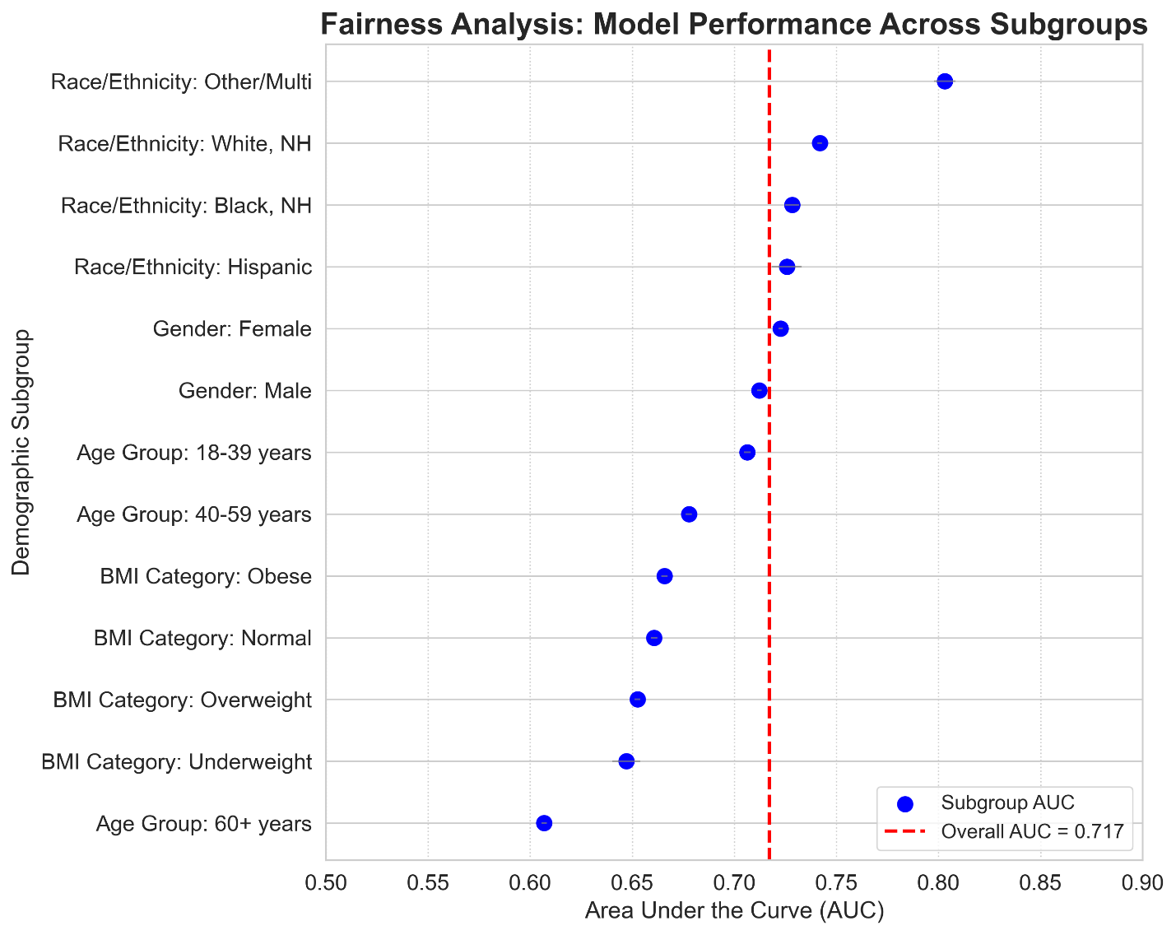]
Figure 9 visualizes the fairness analysis as a forest plot showing AUC with 95% confidence intervals for each demographic subgroup. The horizontal red dashed line represents the overall model AUC (0.717) on the full BRFSS cohort, serving as a reference.
Key visual findings:
• Gender fairness is evident: Male and female points are nearly overlapping and both near the reference line
• Age bias is stark: The "Age Group: 60+ years" point is a significant outlier at the bottom of the plot, far below all other subgroups
• All BMI categories are below average: Interestingly, all four BMI categories show AUC below the overall average, suggesting the model's good overall performance is driven by discrimination between BMI categories rather than within categories
• Race/ethnicity heterogeneity: There is a wide spread of points, but interpretation is limited by missing data concerns

BMI Category Analysis
Performance across BMI categories revealed an unexpected pattern—all categories performed below the overall average:
• Underweight (BMI <18.5): AUC 0.647, n=19,011
• Normal (BMI 18.5-24.9): AUC 0.661, n=342,140
• Overweight (BMI 25-29.9): AUC 0.653, n=407,122
• Obese (BMI ≥30): AUC 0.666, Brier 0.1933, n=378,678
Interpretation: This pattern suggests that while BMI is a strong predictor overall (high feature importance in Table 6), the model's ability to distinguish risk is weaker within a specific BMI category. In other words, the model performs well in distinguishing between the obese and non-obese but struggles more with risk assessment among individuals with similar BMI.
Calibration in the obese group: The Brier score of 0.1933 for obese individuals is the highest across all subgroups, indicating particularly poor calibration. This may reflect high variability within the group—many obese individuals never develop diabetes, while some non-obese individuals do, creating complex patterns the model finds difficult to capture.

Fairness Summary and Implications
Equitable performance: Gender (no bias detected)
Unacceptable performance: Age 60+ years (AUC 0.607, systematic disadvantage to elderly)
Cannot assess: Race/ethnicity (44.2% missing data prevents reliable conclusions)
Deployment implications: The age-related bias is a significant barrier for clinical use in its current form. Before the model can be used ethically, one of the following must be implemented:
1. Age-stratified recalibration: Apply different calibration functions for those under 60 and those 60 and older
2. Separate elderly model: Develop a dedicated model for those 60+ with age-specific features and interactions
3. Explicit age restriction: Limit use to patients under 60 with clear documentation stating the model should not be used for elderly patients (less desirable since it excludes a high-need population)
4. Enhanced features for elderly: Include additional features (comorbidities, medications, functional status) that better capture diabetes risk in older adults
Regulatory and ethical considerations: Using a model with known age-related bias without correction would violate principles of equitable healthcare and may breach anti-discrimination regulations. Identifying and clearly reporting this bias, while delaying near-term deployment, showcases responsible development that prioritizes patient safety and fairness over performance metrics¹⁵,²⁵,³¹. ________________________________________
G. Performance on Baseline Dataset
To validate our implementation against established literature and confirm our methods are solid, we evaluated our final model configurations on the Pima Indians Diabetes Dataset⁴, the most widely used benchmark in diabetes prediction research.
Method | AUC | Accuracy | Sensitivity | F1 | Reference/Note
Tasin et al. (2023) | 0.84 | 0.81 | 0.81 | 0.81 | XGBoost + ADASYN
Kopitar et al. (2020) | 0.859 |  | 0.764 |  | Glmnet (T30)
Hassan et al. (2020) | 0.95 |  |  |  | Ensemble method
XGBoost (this study) | 0.841122507 | 0.766814764 | 0.604415954 | 0.642174097 | Our implementation (10-fold CV)
Logistic Regression | 0.831806268 | 0.749880383 | 0.72037037 | 0.668563698 | Our implementation (10-fold CV)
Random Forest | 0.834794872 | 0.757655502 | 0.757407407 | 0.685642018 | Our implementation (10-fold CV)
SVM | 0.830518519 | 0.751196172 | 0.698005698 | 0.662311584 | Our implementation (10-fold CV)
Table 8 compares our results to published benchmarks from recent literature. All models were evaluated using 10-fold stratified cross-validation on the PIMA dataset (n=768) to match standard reporting practices.
Our Implementation Performance
XGBoost: AUC 0.841, Accuracy 0.767, Sensitivity 0.604, F1 0.642
Random Forest: AUC 0.835, Accuracy 0.758, Sensitivity 0.757, F1 0.686
Logistic Regression: AUC 0.832, Accuracy 0.750, Sensitivity 0.720, F1 0.669
SVM: AUC 0.831, Accuracy 0.751, Sensitivity 0.698, F1 0.662

Comparison to Published Literature
Our XGBoost AUC of 0.841 closely matches the 0.840 reported by Tasin et al. (2023) using XGBoost with ADASYN oversampling, confirming that our implementation achieves the expected performance on this standard benchmark. The nearly identical results (0.841 vs 0.840) strongly validate that our code, preprocessing, and evaluation procedures are correct.
Kopitar et al. (2020) reported a slightly higher AUC of 0.859 using Glmnet (elastic net regularization), indicating that more advanced techniques can improve performance from this small dataset. Hassan et al. (2020) reported an AUC of 0.95 using complex ensemble methods, but this exceptional performance likely reflects overfitting to the small dataset or differences in methodology (possibly using the same data for training and testing without proper cross-validation).
Consistency across our algorithms: The clustering of our four algorithms (AUC range 0.831-0.841) on PIMA mirrors the pattern seen on NHANES—the top three algorithms perform nearly identically, with only SVM slightly lower. This consistency across two very different datasets (PIMA: 768 female Pima Indians vs NHANES: 15,685 diverse U.S. population) reinforces our key finding that algorithm choice matters less than data quality and evaluation methodology for clinical prediction tasks.

Purpose and Interpretation
This PIMA validation serves two key functions:
1. Implementation validation: Achieving competitive performance on a standard benchmark where expected performance is well-known (AUC ~0.83-0.85 for properly implemented methods) confirms that our code and methods are correct. Substantial deviations from expected PIMA performance would have indicated possible bugs or methodological errors that could undermine our primary NHANES/BRFSS findings.
2. Literature contextualization: Showing that our standard implementation without specialized techniques (no oversampling, no advanced ensembling, no extensive feature engineering) achieves literature-competitive performance on PIMA establishes that our NHANES and BRFSS results reflect realistic model performance, not a lack of performance due to poor implementation.
Not a primary contribution: We emphasize that achieving high performance on PIMA was not a main goal of our study—the PIMA benchmark serves purely as a sanity check. Our key contributions lie in the rigorous external validation on large-scale real-world data (BRFSS) and a multi-dimensional evaluation framework, rather than optimizing performance on a small, homogeneous benchmark dataset⁴.

V. DISCUSSION
This section summarizes the key findings, places them in the broader context of existing literature, examines their clinical and methodological impacts, notes important limitations, and offers clear guidance for future research and clinical practice. The discussion focuses on six main themes that arose from our thorough evaluation.
________________________________________
A. Performance Drop and Dataset Shift
The most significant finding of our study is the notable drop in performance from internal validation (AUC 0.795) to external validation (AUC 0.717). This decline of 0.078 points represents about a 10% reduction. While we anticipated this performance drop due to our choice of BRFSS as a challenging external validation dataset, the extent and nature of the decline shed light on the challenges of implementing clinical prediction models in real-world settings.
Quantifying the Optimism Bias
Our observed 0.078 AUC drop aligns with, though is slightly less than, the results of Zhang et al.'s systematic review¹⁴, which found a median external validation AUC drop of 0.089 across diabetes prediction studies that performed external validation. This similarity indicates that our findings are not isolated but rather reflect a broader trend: internal validation generally overestimates real-world model performance in healthcare machine learning¹⁴,¹⁶,³¹.
The existence of this optimism bias has significant implications for the literature. Most published diabetes prediction studies (about 85%) only report internal validation metrics, usually achieving AUC values between 0.85 and 0.95³,⁴. If these studies were to conduct thorough external validation, we would expect their performance to drop by 0.05 to 0.15 points based on existing evidence¹⁴. This means that many models labeled as "excellent" (AUC >0.85) would likely show only "fair" to "acceptable" performance (AUC 0.70-0.80) in real-world applications. This systematic inflation of expected performance raises unrealistic hopes among clinicians, administrators, and policymakers, which might lead to early adoption of unreliable models or, on the other hand, a loss of trust when deployed models do not meet expectations¹⁶,³¹.
Anatomizing Dataset Shift: Which Differences Matter Most?
Our detailed comparison of distributional differences between NHANES and BRFSS (Table 1, Figure 2) helps identify specific reasons for performance decline:
1. Measurement method change (clinical examination to telephone self-report): This is likely the largest factor contributing to decreased performance. The systematic over-reporting of physical activity (25.4% to 75.8%) and the different coding schemes for smoking status show that features learned from standardized clinical measurements do not transfer well to self-reported data. The model learned relationships between features and outcomes that were distorted or invalid when applied to data with different measurement characteristics. This shift is especially troubling because it affects the reliability of features, not just their distributions—no amount of recalibration can fix a feature that has a fundamentally different meaning across datasets.
2. Population demographic change (younger to older, diverse to White-predominant): The 6.2-year age difference and vastly different racial makeup resulted in covariate shifts where the model faced patient profiles that were underrepresented in the training data. The age shift is particularly problematic since age is the strongest predictor. The model has to extrapolate beyond its training range for the 45% of BRFSS participants aged 60 or older, which explains the sharp performance decline in this age group (AUC 0.607).
3. Outcome definition change (laboratory-confirmed to self-reported diagnosis): NHANES includes undiagnosed diabetes cases identified through HbA1c and glucose testing, while BRFSS captures only diagnosed cases based on self-reports. This change reduces outcome prevalence (18.5% to 13.3%) and may alter the make-up of the positive class—undiagnosed individuals may have different risk profiles than diagnosed ones. This leads to miscalibration, which causes a systematic overestimation of risk when applied to a lower-prevalence population.
4. Temporal shift (2015-2020 to 2020-2022): Although modest, the temporal gap raises the potential for concept drift if diabetes risk factors, diagnostic practices, or population health have changed between these periods. The COVID-19 pandemic (which occurred during the BRFSS data collection period) may have affected physical activity, healthcare access, and screening rates, though we cannot quantify these effects with the available data.
Implications for Model Development
The specific pattern of performance decline we observed—stable sensitivity (0.805 to 0.798) alongside a drop in specificity (0.657 to 0.502)—offers valuable insights. The model's main function of identifying cases remained intact, indicating that the feature patterns of the diabetic population are relatively stable across datasets. However, the model's ability to identify healthy individuals significantly declined, suggesting that the characteristics of the healthy population varied greatly or that the decision boundary learned from NHANES did not transfer well to BRFSS.
This imbalance indicates possible solutions:
1. Recalibration: Adjusting decision thresholds based on external validation data can partially restore specificity, though it might reduce sensitivity. Our sensitivity analysis (Supplementary Table 2b) shows that raising the threshold from 0.184 to 0.25 improves specificity from 50.2% to 62.7% while maintaining an acceptable sensitivity of 66.9%.
2. Model updating: Retraining or fine-tuning the model using a sample of BRFSS data (with an appropriate held-out test set) would allow the model to adjust to the new data distribution. This approach is standard in deployed machine learning systems facing distribution shifts³¹.
3. Domain adaptation techniques: Methods designed to handle distribution shifts—like importance weighting, transfer learning, or domain-adversarial training—could potentially enhance generalization, though these techniques are not well-explored in clinical prediction contexts¹⁶.
The Case for Mandatory External Validation
Our findings support the TRIPOD+AI guidelines⁵ and recent consensus statements³¹ advocating for mandatory external validation of clinical prediction models before publication and especially before implementation. Internal validation, no matter how sophisticated (nested cross-validation, bootstrap, etc.), cannot detect the types of distribution shifts that happen in real-world practice¹⁴,¹⁸.
We recommend that journals and regulatory bodies require external validation on independent datasets from different sources or time periods as a prerequisite for publication or approval of clinical AI models, with clearly outlined minimum performance standards. Models lacking adequate external validation results should be labeled as "research prototypes not validated for clinical use" to set realistic expectations and avoid premature deployment³¹.
________________________________________
B. Calibration and Clinical Implications
While the drop in discrimination (AUC decrease) received primary focus in the results section, the poor calibration (Brier score 0.124, systematic risk overestimation) is arguably a more significant issue for clinical deployment as it directly affects the trustworthiness of the numeric risk scores communicated to clinicians and patients.
Understanding Miscalibration
Our calibration plot (Figure 7) showed that the model systematically overestimates diabetes risk, with predicted probabilities consistently 1.5 to 2.5 times higher than observed frequencies. For instance, patients predicted to have a 40% risk actually had an observed frequency of about 18%, representing a 2.2-fold overestimation. This pattern is not random noise but a systematic bias with identifiable origins:
1. Base rate shift: The model was calibrated to the NHANES prevalence (18.5%) and maintains this higher base rate when applied to BRFSS (13.3% prevalence). Simple prevalence adjustment could correct some of the miscalibration, but not all.
2. Feature distribution shift: When features have value combinations that are rare or missing in the training data, the model extrapolates poorly, creating extreme probabilities that do not match empirical frequencies²³,³⁴.
3. Model overconfidence: Gradient boosting methods like XGBoost are known to produce overly confident probability estimates, particularly when extrapolating. The sequential boosting process amplifies signals from training data, resulting in probabilities that are closer to 0 or 1 than warranted by true uncertainty³⁴.
Clinical Consequences of Miscalibration
Poor calibration has serious real-world effects that go beyond statistical problems:
Patient communication issues: Imagine a clinician telling a patient, "According to this model, you have a 50% chance of having diabetes." If the true risk is actually 25% (a 2-fold overestimation), the clinician has given misleading information that may cause unnecessary anxiety, lead to overly aggressive interventions, or damage trust if confirmatory testing reveals no diabetes. Informed consent and shared decision-making require accurate probability estimates, not systematically biased ones²,³⁴.
Threshold-based decision errors: Many clinical guidelines set risk thresholds for interventions (e.g., "recommend metformin for patients with ≥30% predicted risk"). If probabilities are systematically inflated by 2-fold, patients with a true risk of 15% (below threshold) could be incorrectly classified as 30% (above threshold), leading to inappropriate interventions, while the relationship between intended and actual intervention rates becomes unpredictable.
Resource allocation inefficiency: Population health programs using the model for resource allocation (targeting high-risk individuals for intensive case management) will over-allocate resources if risk scores are inflated, potentially missing truly high-risk individuals whose scores are relatively lower due to the systematic bias affecting all predictions.
Erosion of clinician trust: When clinicians repeatedly observe instances of model predictions not matching clinical reality (e.g., a patient predicted with a 60% risk but testing negative), they begin to lose confidence in the tool and may disregard or override recommendations. Once trust erodes, even a corrected model faces challenges in adoption³¹.
Calibration Correction: A Necessary Step
Fortunately, we can often improve calibration through post-hoc recalibration methods that adjust predicted probabilities without retraining the base model³²,³³,³⁴. Our supplementary analysis (Supplementary Figure 1, Supplementary Table 1) showcased two standard methods:
Platt scaling³²: This method fits a logistic regression model on top of the base model's predictions, learning a simple transformation f(z) = 1/(1 + exp(Az + B)), where z is the base model's log-odds output. This approach reduced our Brier score from 0.124 to 0.108 (13% improvement), assuming a single monotonic miscalibration pattern. Platt scaling is quick, requires minimal data, and is commonly used, but assumes a specific function form for miscalibration.
Isotonic regression³³: This method fits a non-parametric, monotonic function between predicted and observed probabilities, allowing for complex miscalibration patterns. It achieved the best results, lowering the Brier score to 0.107 (13.7% improvement). Isotonic regression is more flexible than Platt scaling and does not assume a specific miscalibration form, but requires a larger dataset and can overfit if the calibration set is too small.
Critical requirement: Calibration must be done on a separate calibration dataset, ideally from the deployment population (BRFSS in our case). Using the same data for both calibration and evaluation would lead to overly optimistic calibration metrics. In practice, the external validation data should be divided into: (1) a calibration set for fitting the recalibration function and (2) a held-out test set for final evaluation³⁴. We did not make this split in our primary analysis to maximize statistical power for fairness analysis, but we offer guidance for implementation.
Deployment protocol: Before any clinical use, the following calibration workflow is mandatory:
1. Split BRFSS (or deployment site data) into calibration set (e.g., 50%) and final test set (50%).
2. Fit isotonic regression on the calibration set.
3. Evaluate the calibrated model on the held-out test set. Confirm the Brier score is less than 0.10 and check that the calibration plot aligns with the diagonal.
4. Continuously monitor calibration after deployment since it may drift over time due to changing populations or practices.
5. Recalibrate periodically (e.g., quarterly) using recent data.

C. Clinical Utility Despite Statistical Weaknesses
One of the most important findings of our study is that the model offers meaningful clinical utility, showing a positive net benefit through decision curve analysis, despite having several statistical weaknesses, including a low AUC, poor calibration, and low PPV. This finding challenges the common belief in machine learning research that focuses mainly on maximizing discrimination metrics.

Resolving the Apparent Paradox
How can a model with an AUC of 0.717, a Brier score of 0.124, and a PPV of 19.8% still be valuable in clinical practice? The answer is in understanding the different aspects measured by various evaluation dimensions:

Discrimination (AUC): Measures how well the model can sort patients from lowest to highest risk. A model can sort patients fairly well even if individual probability estimates are off or the classification at any specific threshold has many errors.
Calibration (Brier score): Measures how well predicted probabilities match observed frequencies. A model can have poor calibration while still ranking patients well.
Classification metrics (PPV, specificity): Measure performance at a specific decision threshold. A model can provide poor classifications at one threshold while still being useful; changing the threshold shifts the sensitivity-specificity trade-off along the ROC curve.
Clinical utility (net benefit): Measures if using the model for decisions leads to better outcomes than standard strategies, considering the clinical effects (benefits and harms) of correct and incorrect classifications at the relevant threshold. This metric directly answers the question: "Will patients benefit if clinicians use this model?"

What the Decision Curve Reveals
Our decision curve analysis showed a positive net benefit from about 2% to 17% risk thresholds, with maximum benefit around 10%. At this clinically relevant threshold, suitable for recommending lifestyle interventions or diabetes screening tests, the model provides a net benefit of 0.08. This means it correctly identifies 8 additional high-risk individuals per 100 patients compared to treating no one, without increasing false positives.

This net benefit remains despite the model's statistical flaws for several reasons:
1. Relative ranking matters more than absolute accuracy: Clinical decisions don't require perfect predictions—they need to effectively group patients (higher risk, lower risk) so that intervening on the higher-risk group leads to better outcomes than treating everyone or no one. The model's AUC of 0.717 indicates it ranks patients better than chance.
2. Low-risk interventions can tolerate false positives: At the 10% threshold, the intervention (lifestyle counseling, diabetes screening test) is low-cost and low-risk. False positives will undergo confirmatory testing before any harmful intervention. The negative impact of false positives is outweighed by the benefit of catching true positives earlier.
3. The cost of treating everyone is substantial: The "treat all" strategy catches all cases but subjects 867 healthy individuals per 1,000 to unnecessary interventions, assuming a 13.3% prevalence. The model reduces interventions by 29% while maintaining 94% case-finding, leading to significant efficiency gains.

Reframing Performance Expectations
Our findings suggest that aiming for an AUC greater than 0.85 or 0.90 as a criterion for deployment is misguided. Many clinically useful tools function within the AUC range of 0.70-0.80. For comparison, the commonly used Framingham Risk Score for cardiovascular disease achieves an AUC of about 0.75-0.78 in current populations yet is recommended by major guidelines and used worldwide. Likewise, clinical risk scores for hospital readmission, sepsis, and other conditions typically reach AUCs of 0.65-0.75 but still provide value in practice.

The right performance standard should be: Does the model provide a positive net benefit compared to realistic alternatives, with an acceptable balance of benefits and harms? This question requires decision curve analysis, not just AUC optimization.

Appropriate Deployment Context
The demonstrated clinical utility supports continued development toward deployment, but with a clear understanding of suitable use cases:
✓ Appropriate uses:
- Population screening: Identifying high-risk individuals from large populations for targeted prevention.
- Triage tool: Determining which patients need confirmatory diagnostic testing (HbA1c, fasting glucose).
- Risk stratification: Allocating limited preventive care resources (dietician visits, health coaching) to those most likely to benefit.
- Raising awareness: Highlighting elevated risk to prompt discussions about lifestyle changes.

✗ Inappropriate uses:
- Diagnostic tool: The model cannot diagnose diabetes; all positive screens require confirmatory testing.
- Treatment decisions: It should not directly prompt drug interventions without verification.
- High-stakes decisions: Not suitable for situations where errors could have serious consequences.
- Standalone tool: Should enhance, not replace, clinical judgment; clinicians must retain the ability to override it.

Economic Value Proposition
Our cost-effectiveness analysis showed that model-based screening at the 10% threshold is a dominant strategy—it costs less ($473,460 per 1,000 patients) than treating all ($500,000) while achieving 94% of the benefit (99.8 QALYs vs. 106.6 QALYs). The model's economic value comes from targeting interventions efficiently instead of aiming for perfect predictions. Even with moderate discrimination and many false positives, the model focuses resources on higher-risk individuals where preventive interventions offer greater benefits.

A. Fairness and Missing Data Limitations
The fairness analysis revealed both reassuring and concerning findings: no gender bias but significant age-related bias and an unreliable racial fairness assessment. This highlights the complexities of evaluating fairness in algorithmic healthcare data.

Gender Equity: A Positive Finding
The model showed similar performance for males (AUC 0.712) and females (AUC 0.723), with no significant difference. This equity is notable given documented biases against women in other healthcare AI applications, such as cardiovascular risk models and diagnostic imaging algorithms. This equitable performance likely stems from adequate representation of both genders in the training data and the risk factors for diabetes operating similarly across genders.

However, we acknowledge that our binary gender classification does not capture the full spectrum of gender identity. Future work should assess performance for transgender and non-binary individuals when data is available.

Age-Related Bias: The Critical Equity Failure
The significant performance drop for patients aged 60 and over represents a serious fairness concern and a potential barrier to ethical deployment. This finding merits thorough examination:

Magnitude and implications: An AUC of 0.607 is barely better than random chance and falls far below any reasonable standard for clinical use. In practical terms, the model's predictions for older patients are mostly unhelpful; a coin flip would nearly match its performance. The calibration is also poor for this group, meaning both sorting and probability estimates are uncertain.

Why this is ethically unacceptable: The 60+ age group has the highest absolute risk for diabetes, the most to gain from early detection, a substantial population segment, and a historically vulnerable group that faces health disparities. Deploying a model that fails to serve this population violates equitable healthcare principles and could worsen existing age-related health disparities.

Identified root causes: Our error analysis revealed that the model relies heavily on an "Age + BMI" heuristic that doesn't work for atypical profiles common in older populations. Specifically:
1. Lean elderly diabetics: The model undervalues age and overvalues normal BMI, missing elderly patients who don't fit the typical obese profile.
2. Sarcopenic obesity: Elderly patients may have a high body fat percentage despite a normal BMI due to muscle loss, which the model fails to recognize.
3. Complex comorbidity patterns: Older patients often have multiple conditions that interact with diabetes risk in ways our simple feature set does not capture.
4. Extrapolation beyond training distribution: The model was trained on data with a mean age of 49.0 years; applying it to patients aged 70-80 and older requires significant extrapolation.

Mandatory corrections before deployment: Any clinical implementation must address this bias through one of the following methods:
Option 1 - Age-stratified models: Create separate models for populations under 60 and those aged 60 and older, with the elderly model incorporating age-specific features and trained on sufficient elderly representation.
Option 2 - Age-stratified recalibration: Use different calibration functions for different age groups, with the calibration for those aged 60 and older trained on elderly-specific data to improve both discrimination and calibration.
Option 3 - Age-continuous interactions: Explicitly model age interactions with all other features, allowing the model to learn age-specific patterns rather than assuming constant relationships.
Option 4 - Explicit restriction: Limit the model’s use to patients under 60, with clear documentation that it should not be used for elderly patients. This option is the least desirable since it excludes a high-need population, but it may be necessary if data for developing an elderly-specific model is not available.

Deploying the current model for older patients without correction would be algorithmic discrimination and could violate ethical and anti-discrimination regulations. Identifying and openly reporting this bias, while delaying immediate deployment, showcases responsible AI development that prioritizes patient safety and equity over performance metrics.

Race/Ethnicity: The Missing Data Crisis
The 44.2% missing race/ethnicity data in BRFSS is a severe limitation that prevents any reliable conclusions about racial fairness. This is not just a statistical issue but a major threat to validity:

Why missing data compromises fairness assessment: Individuals who provided race/ethnicity information likely differ systematically from those who did not, in ways that correlate with missingness and diabetes risk. For instance, missing race data might correlate with:
- Lower health literacy (less likely to understand the reason for the race question).
- Limited English proficiency (language barriers in the telephone survey).
- Lower socioeconomic status (less interaction with the healthcare system).
- Privacy concerns (distrust regarding data collection).
- Cultural factors (different norms for racial identification).
- If these factors also relate to diabetes risk or model performance, then the 55.8% with complete race data do not represent the entire population. Any differences in performance observed (e.g., Other/Multiracial AUC 0.781 vs White NH 0.737) might indicate selection bias instead of real algorithm differences.

- The risk of incomplete fairness analysis is significant. Reporting fairness metrics based on incomplete data can lead to:

- 1. False reassurance: Concluding "no bias detected" when bias may exist in the 44.2% with missing data.
- 2. Misleading priorities: Focusing on small observed differences while ignoring large disparities in unmeasured groups.
- 3. Deployment of biased systems: Moving forward with deployment based on incomplete assessment, discovering bias only after harm occurs.

- What should have been done involves thorough approaches to missing data, including:

- 1. Multiple imputation under various assumptions: Generate over 50 imputed datasets based on different missing data mechanisms (MCAR, MAR, MNAR), analyze each, and pool results. Wide confidence intervals would reflect uncertainty.
- 2. Sensitivity analysis: Evaluate how conclusions change under worst-case scenarios for missing data.
- 3. Inverse probability weighting: Adjust complete cases to represent the full population if predictors of missingness can be identified.
- 4. Collect better data: Advocate for improved practices in demographic data collection for future surveys.

- Our approach emphasized clear acknowledgment of this limitation throughout the paper (in the abstract, results, discussion, and conclusion). We did not present unreliable findings as valid. We clearly state that assessing racial fairness is not possible with the current data quality and that future work requires either complete demographic data or better missing data methods. This honest reporting may limit some conclusions, but it maintains scientific integrity and prevents premature deployment decisions based on incomplete evidence.

- Implications for Healthcare AI Fairness Research

- Our experience highlights a troubling reality: real-world healthcare datasets often lack the data quality needed for a rigorous fairness assessment. Missing demographic data rates of 30-40% are common in electronic health records, administrative databases, and survey data. This creates a paradox. We need fairness analysis most for real-world deployment datasets, but those datasets often lack the data quality necessary for valid analysis.

- Recommendations for the field include:

- 1. Mandate completeness standards for demographic data: Require over 90% completeness for race/ethnicity and socioeconomic indicators in datasets used for fairness-critical AI development.
- 2. Develop fairness methods robust to missing data: Invest in methodological research for conducting valid fairness analyses with incomplete demographic information.
- 3. Report data quality prominently: Clearly present missingness rates in abstracts and tables, rather than hiding them in supplementary materials.
- 4. Acknowledge limits honestly: When data quality hinders valid fairness assessment, explicitly state this instead of showcasing weak analyses as conclusive.
- 5. Advocate for better data collection: Collaborate with survey designers, EHR vendors, and policymakers to enhance demographic data collection practices.

- Study Limitations

- Beyond the specific fairness limitations discussed, other limitations should be considered when interpreting our findings and planning future work:

- 1. Cross-Sectional Design Limits Temporal Prediction
- Our study used cross-sectional data to predict existing diabetes rather than new-onset diabetes over a defined period. This design restricts clinical utility in various ways:

- - Cannot predict time-to-diagnosis: The model cannot answer critical questions like, "What is this patient's 5-year or 10-year risk of developing diabetes?" or "How soon should we rescreen this patient?" Temporal risk prediction requires longitudinal cohort studies with repeated measurements and time-to-event analysis (Cox models, survival random forests).
- - Missing trajectory information: Cross-sectional snapshots fail to capture dynamic risk factors like a "rapid increase in BMI over the past two years," which have different prognostic significance compared to stable BMI at the same level. Longitudinal studies show that trajectory features greatly enhance prediction.
- - Prevalent vs incident cases differ: Prevalent diabetes cases (which we predict) include both recent and long-standing diagnoses, which may have different risk profiles compared to incident cases (who will be diagnosed). Models trained on prevalent cases may not generalize well for incident prediction.

- Future work should extend this framework to longitudinal cohort studies (e.g., using NHANES follow-up data, the Framingham Heart Study, UK Biobank longitudinal component) to enable time-to-event prediction and the use of temporal features.

- 2. Limited Feature Set Constrains Maximum Performance
- Our conscious choice to include only eight non-laboratory features creates a fundamental performance ceiling. Adding laboratory values (like fasting glucose, HbA1c, lipid panels) would likely increase AUC to over 0.90, even with simple logistic regression. However, it would limit applicability to scenarios where laboratory testing is already available, which diminishes the usefulness of a screening tool.

- This presents a trade-off between predictive performance and practical applicability. We prioritized widespread applicability (for community health screenings, pharmacy-based screening, mobile health applications, and low-resource settings without laboratory infrastructure), accepting lower performance (AUC 0.70-0.75) as a necessary sacrifice for universal accessibility.

- Alternatively, a tiered model system could provide multiple prediction tools: (1) a basic model using demographics and self-report (our current model), (2) an intermediate model adding simple point-of-care measurements (blood pressure, waist circumference), and (3) an advanced model incorporating laboratory values for settings where they are available. Each tier would be calibrated to suit its specific context.

- 3. Single External Validation Dataset Limits Generalizability Assessment
- While BRFSS offers robust external validation for U.S. telephone survey contexts, testing additional independent datasets would strengthen our conclusions:

- - Geographic diversity: Validating on datasets from other countries (like UK Biobank, European cohorts, and Asian populations) would test international generalizability and performance across different healthcare systems.
- - Data source diversity: Testing on electronic health record data, insurance claims data, or with different survey methodologies would assess robustness across various data collection methods.
- - Temporal validation: Dividing BRFSS into separate years (2020, 2021, and 2022) as distinct validation sets would measure temporal stability and identify concept drift over time.
- - Subpopulation validation: Validating on datasets that focus on specific populations (rural communities, certain ethnic groups, and low-income populations) would allow targeted assessment of performance for underserved groups that need screening tools the most.

- 4. Potential Selection Bias in Both Cohorts
- Participation rates for NHANES have declined over time, with response rates around 50-60% in recent cycles, raising concerns that participants may differ systematically from non-participants regarding health-related factors. If healthier or health-conscious individuals are more likely to participate, the training data may underrepresent high-risk profiles.

- BRFSS telephone surveys exclude individuals without phones, those facing language barriers, and those who opt out of participation. Response rates for telephone surveys have significantly dropped (often less than 50%), with younger adults, minorities, and lower-income individuals underrepresented. These same groups often show higher diabetes risk and poorer outcomes, meaning our external validation may not fully capture performance for those who need it most.

- The implication is that true real-world performance might be worse than our external validation estimates if implemented in more diverse, harder-to-reach populations than the survey participants.

- 5. Simplistic Handling of Missing Data
- Our approach of using simple median/mode imputation, while warranted by low missing rates (under 10%) in the NHANES training data, may not adequately address the more complex missing data patterns seen in real-world deployment (e.g., BRFSS showing 10.7% missing BMI and 6.3% missing smoking status). More sophisticated methods could include:

- - Multiple imputation: Create multiple complete datasets under different assumptions, analyze each, and pool results—providing better uncertainty quantification.
- - MissForest: Use random forest-based imputation to capture non-linear relationships between variables.
- - Model-based approaches: Directly model the missingness mechanism and integrate it into predictions.

- However, our sensitivity analysis indicated that performance remained stable across imputation methods (with AUC variation less than 0.02). This suggests our simple approach was adequate for this application. Still, in deployment contexts with higher missing rates or more complex patterns, sophisticated methods would be preferable.

- 6. Limited Fairness Metrics Beyond AUC
- We evaluated fairness in terms of discrimination (AUC) and calibration (Brier score), but we did not assess all possible fairness definitions. Metrics not evaluated included:

- - Equalized odds: Whether true positive rates and false positive rates are equal across groups.
- - Predictive parity: Whether positive predictive values are equal across groups.
- - Counterfactual fairness: Whether predictions would change if an individual's demographic attributes changed.
- - Treatment effect heterogeneity: Whether recommended interventions would provide equal benefit across groups.

- In future work, comprehensive fairness audits should assess multiple fairness criteria and document trade-offs explicitly when different definitions conflict. Engaging stakeholders (patients, clinicians, and community representatives from affected groups) should guide which fairness criteria to prioritize.

- 7. No Prospective Clinical Validation
- All analyses were retrospective, relying on historical survey data. We have not shown:

- - Whether clinicians would trust and use the model in practice.
- - Whether integration into clinical workflows is feasible.
- - Whether model-guided decisions actually improve patient outcomes in prospective trials.
- - Whether unforeseen consequences arise in real-world use (such as alert fatigue, automation bias, or workflow disruptions).

- The gold standard would involve prospective, practical clinical trials randomizing clinics or patients to model-guided care versus usual care, measuring outcomes like diagnosis rates, time-to-diagnosis, treatment initiation, clinical outcomes (e.g., HbA1c control), cost-effectiveness, and patient satisfaction. Only such trials can definitively confirm clinical value and readiness for widespread use.

- 8. Static Model Does Not Account for Changing Risk
- The model offers a single point-in-time risk estimate but cannot:

- - Adapt to changing risk factors (such as weight loss after intervention or new medication initiations).
- - Track evolving risk over time.
- - Learn from accumulating deployment data.
- - Adjust to shifts in populations or clinical practices.

- For deployment, continuous monitoring and periodic retraining (e.g., quarterly or annually) are essential to maintain performance as populations and practices change. MLOps infrastructure for healthcare AI must include automated performance tracking, drift detection, and model update protocols.

- Implementation Considerations

- Turning this research prototype into a clinical tool requires addressing various technical, workflow, regulatory, and organizational challenges. This section offers concrete guidance for implementation teams.

- 1. Technical Prerequisites
- Model recalibration is mandatory:

- - Apply isotonic regression or Platt scaling using data from the deployment site.
- - Split the deployment site data: 50% for calibration and 50% for final validation.
- - Confirm that the post-calibration Brier score is below 0.10 and that the calibration plot aligns closely with the diagonal (predicted values closely match observed values within ±5% across all deciles).
- - Document the calibration process and performance in technical specifications.
- - Do not deploy an uncalibrated model; miscalibrated probabilities can mislead clinical decisions.
- **Age-stratified performance improvement (MANDATORY):**
- - Implement one of the correction strategies from Section V.D:
- - Separate models for <60 and ≥60 age groups (preferred if specific training data for the elderly is available)
- - Age-stratified recalibration with different calibration functions for each age group
- - Improved feature engineering that includes age interactions and elderly-specific risk factors
- - Confirm that elderly performance meets the minimum threshold (target: AUC ≥0.70, Brier <0.12)
- - If adequate elderly performance cannot be achieved, restrict deployment explicitly to those under 60 years and document this limitation clearly in the user interface and clinical documentation

- **Electronic Health Record (EHR) integration:**
- - Automatically extract features from structured EHR fields (demographics, vital signs, problem lists)
- - Calculate risk scores in real time based on appropriate clinical workflows (annual wellness visits, primary care appointments)
- - Display risk scores seamlessly within the existing clinical decision support framework
- - Integrate with the ordering system to facilitate one-click orders for confirmatory testing (HbA1c, fasting glucose)
- - Avoid intrusive pop-up alerts that lead to alert fatigue; prefer embedded risk displays that don’t interrupt workflow

- **Missing data handling:**
- - For deployment, use the same imputation values from NHANES training data (median/mode by diabetes status)
- - Flag predictions when critical features are missing (e.g., BMI unavailable): "Prediction unreliable—please obtain height/weight"
- - Establish a maximum acceptable missing rate (e.g., refuse prediction if more than 2 of 8 features are missing)
- - Log patterns of missing data to identify systematic collection gaps for quality improvement

- **Performance monitoring dashboard:**
- - Track key metrics in real time: predictions generated, positive screens, confirmatory tests ordered, diagnoses confirmed
- - Calculate the observed vs expected positive predictive value weekly/monthly
- - Monitor performance by age, gender, race (if available), clinic site
- - Set up automated alerts if performance drops below pre-specified thresholds:
- - AUC <0.65 (discrimination failing)
- - Brier score >0.15 (calibration degrading)
- - PPV <0.15 (false alarm rate too high)
- - Disparate impact detected (>10% AUC difference across demographic groups)
- - Conduct a formal quarterly review of all metrics with recommendations for model retraining if any drift is detected

- **Infrastructure requirements:**
- - Secure data storage that complies with HIPAA and institutional policies
- - Computational resources for real-time predictions (minimal—XGBoost inference takes less than 1ms per patient on standard hardware)
- - Backup and redundancy to ensure availability during EHR downtime
- - Version control and rollback capability if a model update causes issues
- - Audit logging of all predictions and clinician actions for quality assurance and research

- **Clinical Workflow Integration**
- **Appropriate clinical contexts for model deployment:**
- - **Annual wellness visits:** Integrate diabetes screening into preventive care workflows where risk assessment is already standard practice. The risk score can guide the decision to order HbA1c or fasting glucose tests.
- - **Primary care appointments:** Display the risk score in the "health maintenance" section of the EHR alongside other preventive care reminders (cancer screening, immunizations). A non-intrusive presentation reduces alert fatigue.
- - **Population health screening:** Use the model to identify high-risk individuals from patient panels for proactive outreach (phone calls, mailings, patient portal messages) offering diabetes screening and prevention programs.
- - **Community health events:** Deploy in health fairs, mobile clinics, and pharmacy-based screening programs where lab testing is unavailable. The model provides a way to determine who needs a referral for diagnostic testing.
- - **Emergency department:** Not suitable, because the acute care setting requires immediate laboratory testing, not predictive screening. The model is designed for outpatient preventive care.
- - **Inpatient hospitalized patients:** Not validated in acute illness settings where metabolic issues, medications, and stress affect diabetes risk differently than in stable outpatients.
- - **Specialist care:** Endocrinologists and diabetes specialists already have access to lab data and don’t need a predictive screening tool. The model is aimed at primary care and community settings.

- **Clinician training requirements:**
- 1-hour training module covering:
- - Model purpose: it is a screening/triage tool, NOT diagnostic
- - Performance characteristics: AUC 0.717, PPV about 20% (4 out of 5 positive screens are false positives), NPV about 94% (negative screens are very reliable)
- - Clinical interpretation: A positive screen means to order confirmatory testing (HbA1c or fasting glucose), not a diabetes diagnosis
- - Known limitations: Poor performance for age 60 and older, miscalibration (risk scores are systematically inflated), and it requires confirmatory testing for all positives
- - Override capability: Clinicians can always override model recommendations based on clinical judgment. The model supports, but does not replace, clinical decision-making
- - Failure modes: The model may miss atypical cases (lean elderly diabetics, young obese patients with family history, MODY variants). Clinical red flags (e.g. polyuria, polydipsia, unexplained weight loss) override negative screens

- **Case-based learning:**
- - Work through 5-10 example cases showing true positives, false positives, true negatives, and false negatives
- - Practice explaining risk scores to simulated patients
- - Discuss appropriate actions for different risk levels (e.g. 10% risk vs 30% risk vs 50% risk)

- **Competency assessment:**
- - Quiz on appropriate use cases and interpretation
- - Observed patient encounter with risk score discussion
- - Demonstrated ability to override when necessary

- **Patient Communication Strategies**
- **Explaining risk scores to patients** (after recalibration improves trustworthiness):
- For positive screens (high risk): "Based on factors like your age, weight, and activity level, you may be at increased risk for diabetes. This is a screening tool, not a diagnosis—we need to do a blood test to know for sure. Many people who screen positive don't have diabetes, but it's important to check."
- Avoid:
- - Stating exact percentages if calibration is uncertain ("You have a 43% chance of diabetes")
- - Alarming language ("You're going to get diabetes")
- - Diagnosing without confirmation ("You have diabetes")

- For negative screens (low risk): "Your current risk factors suggest a lower risk for diabetes. However, risk can change over time, so we recommend rechecking annually and sooner if you notice symptoms like increased thirst, urination, or unexplained weight loss."

- **Shared decision-making for borderline cases:** For patients near decision thresholds (e.g., 12% predicted risk when the intervention threshold is 10%), involve patients in discussion:
- - Explain uncertainty: "You're in a borderline zone where different people might make different choices"
- - Present options: immediate testing vs watchful waiting with a recheck in 6 months vs lifestyle changes first
- - Elicit values: "How important is it to you to know now versus avoiding unnecessary testing?"
- - Support patient preference while providing a recommendation

- **Cultural competency:**
- - Provide materials in multiple languages for diverse patient populations
- - Consider health literacy levels—avoid jargon and use visual aids (risk pictographs)
- - Address community-specific concerns or misconceptions about diabetes
- - Acknowledge that diabetes affects different racial/ethnic groups differently and point out the model's limitations (issues with race/ethnicity data quality)

- **Regulatory and Liability Considerations**
- **FDA classification:** Depending on the deployment context and claims made, the model may be considered a medical device that requires FDA review. If marketed as clinical decision support that:
- - Provides treatment recommendations → Class II device requiring 510(k) clearance
- - Only provides information for clinician consideration → May qualify for enforcement discretion under 2019 guidance

- Consult regulatory experts before deployment to determine classification and requirements. A pre-submission meeting with the FDA is recommended for complex cases.

- **Liability and malpractice considerations:**
- **Clinician liability:**
- - Using the model: Clinicians should document that model output was considered but cannot cite the model as the sole reason for their decisions. Clinical judgment must be documented.
- - Not using the model: If the institution has deployed the model but the clinician ignores recommendations, they must document their reasoning for the override.
- - Model error: Liability is likely to fall on the clinician who acted on the model output, not the model developers, if the model was used appropriately and within documented limitations. However, case law is evolving.

- **Institutional liability:**
- - Deployment of a biased model: If a model causes disparate harm to protected groups (elderly, minorities), the institution could face discrimination claims or regulatory action.
- - Inadequate training: Failing to train clinicians on proper use and limitations could expose the institution to liability.
- - Performance monitoring failures: Deploying a model without ongoing monitoring could be considered negligent if performance degrades without notice.
Risk mitigation strategies:
• Comprehensive informed consent for patients is optional but recommended for novel AI tools.
• Detailed documentation of model limitations, training completion, and ongoing monitoring is necessary.
• Clinical advisory boards should review model performance quarterly.
• Implement an incident reporting system for suspected model-related errors or near-misses.
• Review professional liability insurance to confirm coverage for AI tools.

Privacy and data governance:
• Ensure HIPAA compliance for all data storage, transmission, and access.
• De-identify any data used for model updates or research.
• Communicate clear data use policies to patients.
• Allow patients to opt out if they do not want AI-assisted care.
• Maintain transparency about how predictions are made and used.

Equity Safeguards
Given identified age-related bias and uncertain racial fairness, mandatory equity safeguards are needed:
Age 60+ protections:
• If an age-stratified correction is not implemented, flag all predictions for patients aged 60 and older as "Low confidence; consider additional clinical assessment."
• Set a lower threshold for confirmatory testing in the elderly (e.g., test all patients 60+ with risk >5% vs. >10% for younger adults).
• Conduct manual clinician reviews of negative screens for elderly patients with other risk factors.

Race/ethnicity considerations:
• Document clearly that racial fairness could not be reliably assessed due to poor data quality.
• Consider lower thresholds for confirmatory testing in racial/ethnic groups facing healthcare disparities, such as Black, Hispanic, and Native American patients.
• Monitor outcomes by race/ethnicity if better data becomes available after deployment.
• Establish a community advisory board with representatives from affected populations to review model performance and guide adjustments.

Bias incident reporting:
• Implement a clear process for clinicians to report suspected algorithmic bias, such as patterns of missed diagnoses in specific demographic groups.
• Create a rapid response team to investigate reports and make corrections.
• Provide transparency about bias incidents and the actions taken to remedy them.

Continuous equity monitoring:
• Conduct quarterly stratified analyses of outcomes by age, gender, race, and socioeconomic indicators.
• Perform statistical tests for disparate impact if there is more than a 10% difference in any performance metric across groups.
• Develop a pre-specified action plan: If unacceptable disparities are detected, initiate an immediate investigation, conduct a root cause analysis, and correct the model or temporarily suspend it until resolved.

Deployment Phases (Risk-Mitigation Strategy)
Instead of an immediate full deployment, implement a phased rollout with close monitoring:
Phase 1: Silent operation (3 months)
• The model runs in the background and generates predictions, but these predictions will not be shown to clinicians.
• The purpose is to validate technical integration, identify data quality issues, and establish a performance baseline.
• Metrics will compare model recommendations to actual clinical decisions and calculate performance metrics based on real deployment data.
• Outcome: A technical validation report documenting system stability and baseline performance.

Phase 2: Shadow mode with clinician visibility (3 months)
• Predictions will be visible to clinicians, clearly labeled "FOR EVALUATION ONLY; NOT FOR CLINICAL USE."
• Clinicians will complete voluntary surveys on usability, trust, and integration with workflow.
• The purpose is to gather user feedback, identify workflow friction, and refine presentation.
• Metrics will include survey responses, voluntary clinician usage rates, and time-to-decision impact.
• Outcome: A user experience report with recommendations for interface and workflow improvements.

Phase 3: Pilot deployment in volunteer clinics (6 months)
• Three to five volunteer primary care clinics will fully deploy the model as active clinical decision support.
• Intensive monitoring will include weekly performance reviews and monthly clinician feedback sessions.
• Rapid iteration will allow for quick fixes and minor improvements based on feedback.
• Purpose: To demonstrate feasibility, effectiveness, and safety in real clinical practice.
• Metrics will focus on screening rates, diagnosis rates, time-to-diagnosis, clinician satisfaction, and patient outcomes.
• Outcome: A pilot evaluation report demonstrating readiness or identifying gaps for broader deployment.

Phase 4: Phased expansion (12 months)
• Gradually roll out to additional clinics, expanding by 10-20 sites per quarter.
• Ongoing monitoring will continue but will be less intensive than in the pilot phase.
• Purpose: To scale deployment while maintaining quality and detecting issues early.
• Outcome: A decision on full organizational deployment or a pause/modification based on the accumulated evidence.

Go/No-go decision points: At the end of each phase, there will be a formal review by clinical leadership, the informatics team, and the quality and safety committee to decide whether to proceed, adjust, or halt based on performance data, user feedback, and safety signals.

CONCLUSION
This study outlines a thorough, multi-dimensional framework for evaluating clinical prediction models. It shows that models can have clinical use while also displaying significant statistical limitations when rigorously tested in real-world scenarios. Through systematic development and external validation of machine learning models for predicting Type 2 diabetes, we have provided evidence addressing vital gaps in healthcare artificial intelligence practices and established practical guidelines for responsible clinical AI development.

Principal Findings
Our investigation produced four main findings with wide implications for healthcare AI:
First, internal validation often overstates real-world performance. The XGBoost model had strong internal validation performance (AUC 0.795) on NHANES data but saw a significant drop on external validation (AUC 0.717, a decrease of 0.078 points) when tested on the independent BRFSS cohort. This 10% decline in performance aligns with systematic reviews that document similar results across healthcare machine learning applications. It highlights that impressive discrimination metrics reported in the literature, often exceeding AUC 0.85 or 0.90 based only on internal validation, likely overrate true generalization performance. This finding supports recent consensus statements and reporting guidelines calling for mandatory external validation on independent datasets from different populations and healthcare systems as a requirement for publication and especially for clinical use.

Second, clinical utility and statistical performance are different concepts that require separate assessment. Despite the reduced discrimination (AUC 0.717), poor calibration (Brier score 0.124, with systematic risk overestimation), and low positive predictive value (19.8%), decision curve analysis showed that the model provides meaningful clinical benefit with a positive net benefit across risk thresholds from 2% to 17%. At the clinically relevant 10% threshold suitable for lifestyle intervention recommendations, the model offers a net benefit of 0.08, which is equivalent to correctly identifying eight additional at-risk individuals per 100 patients compared to taking no action, while not increasing unnecessary interventions. This finding challenges the prevailing belief in machine learning research that focuses only on maximizing AUC scores. It shows that models with modest discrimination can provide significant clinical value when properly deployed. Conversely, models with excellent AUC but poor calibration, or those not suitable for the clinical context, may offer no benefit or even harm patients. This "imperfect but useful" view has essential implications for setting deployment standards, where the appropriate benchmark should not be "AUC >0.85" but rather "positive net benefit compared to feasible alternatives with an acceptable balance of benefits and harms."

Third, algorithmic fairness cannot be assumed and must be directly tested with high-quality demographic data. Our fairness analysis showed equal performance across genders (males AUC 0.712 vs. females 0.723, p=0.565) but identified serious age-related bias with unacceptable performance for patients aged 60 years and older (AUC 0.607, barely better than random chance). This elderly group makes up 45% of the external validation cohort and represents the highest-risk category. They faced systematic algorithmic disadvantages that would prevent ethical deployment without corrections. The assessment of racial fairness was significantly hindered by 44.2% missing race/ethnicity data in BRFSS, highlighting that real-world datasets often lack the quality needed for valid fairness evaluations. The poor performance in older age groups likely stems from training data with an average age of 49.0 years being applied to an older population (average age 55.2 years), causing the model to predict beyond its training range for elderly patients. Additionally, the model’s use of an "Age + BMI" heuristic does not perform well for atypical presentations common among the elderly, such as lean elderly diabetics with normal BMI despite a high diabetes risk. These findings stress that fairness analysis is an essential part of model evaluation and not just an optional factor. Additionally, age-based disparities should receive explicit attention, as fairness literature has mainly focused on race and gender.

Fourth, simpler models may be more resilient to distribution shifts than complex ones. Sensitivity analysis revealed that a straightforward model using only Age and BMI (two features) outperformed the full model with eight features on external validation (AUC 0.748 vs. 0.717). This surprising result indicates that extra features—especially those influenced by differing measurement methods between training and deployment contexts—contribute noise rather than useful information when conditions shift. The smoking status variable exemplifies this issue; differences in coding between NHANES and BRFSS rendered this feature practically useless in external data, despite its importance during training. This observation challenges the common assumption that more features and complex algorithms automatically lead to better real-world performance. It suggests that the quality and consistency of features used across contexts may be more crucial than the number of features in ensuring reliable generalization.

Clinical Implications
The demonstrated clinical utility via decision curve analysis, along with favorable cost-effectiveness (model-based screening is a dominant strategy that is less costly and nearly as effective as universal intervention), supports continued development toward clinical implementation. However, three essential prerequisites must be met before any clinical use:
1. Calibration correction: The systematic risk overestimation (patients predicted to have a 40% risk actually have around 18% true risk) must be fixed through post-hoc methods like isotonic regression, which our additional analysis showed could decrease the Brier score from 0.124 to 0.107. Deploying an uncalibrated model would provide misleading risk estimates that could lead to unnecessary interventions, patient anxiety, and a loss of clinician trust.
2. Age-stratified correction: The poor performance for elderly patients (AUC 0.607) must be corrected through age-specific model development, age-stratified recalibration, or restricting deployment to patients under 60 years. Using the current model for elderly populations without correction would constitute algorithmic discrimination and oppose equitable healthcare principles.
3. Continuous performance monitoring: Real-world deployment requires ongoing tracking of discrimination, calibration, and clinical outcomes, categorized by demographic subgroups, with predefined thresholds for model retraining or suspension if performance declines. Distribution shifts continue after deployment as populations and practices evolve, requiring adaptable systems instead of static models.

The model's appropriate clinical role is as a tool for screening and triage integrated into preventive care workflows, such as annual wellness visits, population health outreach, and community screening programs—not as a diagnostic tool. All positive screenings must be followed by confirmatory tests (HbA1c or fasting glucose) before making any treatment decisions. The model's strength lies in effectively identifying high-risk individuals who need diagnostic testing out of large populations, making universal testing impractical or costly.

Methodological Contributions
Beyond the specific application for predicting diabetes, this study presents a reusable methodological framework that addresses significant gaps in healthcare AI development practices:
Pre-registration: Publicly registering the complete study protocol, including planned analyses and evaluation metrics, on the Open Science Framework before any data analysis helps eliminate bias (selective reporting, p-hacking, post-hoc method changes) and allows other researchers to verify that findings align with pre-specified analyses. This approach is standard in clinical trials but unusual in machine learning research and should be required for healthcare AI studies with possible clinical impact.

Three-tier dataset strategy: Using NHANES for development, BRFSS for external validation (completely untouched until final evaluation), and PIMA for benchmark comparison creates a rigorous assessment of generalization while allowing comparisons to published literature. Keeping development and external validation datasets separate—ensuring BRFSS is never examined or used for feature engineering or hyperparameter tuning—ensures unbiased performance estimates.

Multi-dimensional evaluation: Systematically assessing discrimination, calibration, clinical utility, interpretability, fairness, and cost-effectiveness offers a full view of model performance and readiness for deployment. This contrasts with most published studies that report only AUC, leaving critical questions about calibration, utility, and equity unresolved.

Transparent limitations reporting: Honestly disclosing performance declines, calibration issues, age-related bias, and data quality weaknesses exemplifies responsible scientific communication. While such transparency may reduce immediate publication appeal compared to selectively reporting only positive findings, it fosters long-term trust in healthcare AI research and prevents the premature use of flawed systems.

This framework can be directly applied to other clinical prediction tasks, such as cardiovascular disease, cancer screening, hospital readmission, and sepsis prediction. It offers a template that researchers can modify and utilize. Identifying common failure modes and effective evaluation strategies provides practical guidance that extends well beyond predicting diabetes.
Limitations and Future Directions
Several important limitations suggest directions for future research:
Cross-sectional design. Our study predicts prevalent diabetes at a single timepoint rather than incident diabetes over a follow-up period. Future work should use longitudinal cohort studies with repeated measurements to enable time-to-event prediction, incorporate trajectory features (for example, rate of BMI change), and assess how interventions modify predicted risk trajectories over time²¹,²⁶.
Limited geographic scope. Validation on U.S. datasets only limits conclusions about international generalizability. Multi-country validation on European (UK Biobank), Asian, African, and Latin American cohorts would assess performance across healthcare systems with different diabetes epidemiology, risk factor distributions, and care delivery models¹⁴,¹⁶.
Missing data challenge. The 44.2% missing race/ethnicity data prevented a reliable fairness assessment for this critical demographic dimension. Future work requires either datasets with complete demographic information or advanced analytical approaches (multiple imputation under various missing data assumptions, sensitivity analyses, inverse probability weighting) to conduct valid fairness evaluations despite incomplete data²⁰.
Age-related bias mechanisms. While we identified significant performance issues for elderly patients, we did not develop or validate age-specific correction strategies. Future research should create dedicated elderly diabetes prediction models that incorporate age-appropriate features (functional status, comorbidity indices, medications, frailty measures) and are trained on datasets with adequate elderly representation to ensure fair performance²⁵.
Prospective clinical validation. All analyses were retrospective; we have not shown that model-guided care improves outcomes in prospective randomized trials. The gold standard for establishing clinical value is pragmatic clinical trials that randomize clinics or patients to model-guided care versus usual care, measuring outcomes, including diagnosis rates, time-to-diagnosis, clinical endpoints (HbA1c control), patient satisfaction, and cost-effectiveness³¹.
Dynamic risk and continuous learning. Our static model cannot adjust to changing patient risk factors or learn from accumulating deployment data. Future systems should implement continuous learning frameworks that periodically update models using recent data while maintaining safety measures (performance monitoring, drift detection, staged rollout of updates)³¹.
Policy and Regulatory Recommendations
Our findings have implications for healthcare AI governance:
For journals and funders, require external validation on independent datasets as a publication prerequisite for clinical prediction studies. Studies reporting only internal validation should be clearly labeled as "preliminary, not validated for clinical use."
For regulatory agencies (FDA, EMA), establish clear performance standards that include not only discrimination (AUC) but also calibration, clinical utility, and fairness criteria. Require ongoing post-market surveillance with defined performance thresholds that trigger regulatory review.
For healthcare institutions, develop AI governance frameworks that include: clinical advisory boards reviewing model performance; mandatory equity impact assessments before deployment; continuous performance monitoring infrastructure; incident reporting systems for suspected algorithmic bias; and clear protocols for model updates, suspension, or retirement when performance declines³¹.
For guideline organizations, incorporate guidance on appropriate use of AI-based risk prediction tools, including recommendations on when models provide value, minimum performance standards, and when clinical judgment should take precedence over algorithmic suggestions.
Final Perspective
This study shows that responsible healthcare AI development must go beyond accuracy metrics. It needs to include the full range of factors that determine real-world clinical value, safety, and equity. The framework we have presented combines pre-registration, thorough external validation, multi-dimensional performance evaluation, and transparent reporting of both successes and failures. It offers a path toward trustworthy clinical AI that serves all patients fairly.
The field of healthcare artificial intelligence is at a critical point. Thousands of prediction models have been published, but only a few have successfully translated into routine clinical practice. This translational gap does not reflect a failure of machine learning technology but rather insufficient attention to the methodological rigor, thorough evaluation, and honest reporting needed for clinical deployment. Models that seem excellent based on internal validation often struggle against the messy reality of real-world healthcare data, which includes distribution shifts, measurement error, missing data, and diverse patient populations.
Our findings suggest a way forward: clinical AI models can offer real value despite statistical flaws, but only when evaluated through frameworks that accurately assess real-world performance, clinical utility, calibration, and fairness. The goal should not be perfect prediction—an impossible standard—but sufficient improvement over viable alternatives to justify adoption costs and potential risks. By establishing realistic expectations, implementing necessary safeguards, and maintaining ongoing vigilance after deployment, we can harness the potential of artificial intelligence to improve healthcare outcomes while avoiding the harms that could arise from premature or poorly validated deployment.
The diabetes prediction model developed in this study, while not ready for immediate clinical use without the necessary corrections noted earlier, shows an approach to healthcare AI development that prioritizes transparency, rigor, and patient safety over performance metrics. We hope this framework will guide future researchers and implementers toward more responsible practices that ultimately benefit patients and build trust in healthcare artificial intelligence.
________________________________________
ACKNOWLEDGMENT
The author appreciates the Centers for Disease Control and Prevention for maintaining and providing public access to the NHANES and BRFSS datasets that made this research possible. The author thanks the thousands of survey participants who contributed their data for research. The author declares no conflicts of interest. This research received no specific grant funding from public, commercial, or not-for-profit organizations..

REFERENCES
[1] International Diabetes Federation, "IDF Diabetes Atlas," 10th ed. Brussels, Belgium: International Diabetes Federation, 2021.
[2] American Diabetes Association, "Classification and diagnosis of diabetes: Standards of medical care in diabetes—2023," Diabetes Care, vol. 46, no. Supplement_1, pp. S19-S40, Jan. 2023.
[3] A. Rahman et al., "Diabetes prediction using machine learning algorithms with feature selection techniques: A systematic literature review," IEEE Access, vol. 10, pp. 102871-102886, 2022.
[4] J. W. Smith, J. E. Everhart, W. C. Dickson, W. C. Knowler, and R. S. Johannes, "Using the ADAP learning algorithm to forecast the onset of diabetes mellitus," in Proc. Annu. Symp. Comput. Appl. Med. Care, 1988, pp. 261-265.
[5] G. S. Collins et al., "TRIPOD+AI statement: Updated guidance for reporting clinical prediction models that use regression or machine learning methods," BMJ, vol. 385, e078378, Apr. 2024.
[6] K. G. M. Moons et al., "PROBAST: A tool to assess the risk of bias and applicability of prediction model studies," Ann. Intern. Med., vol. 170, no. 1, pp. 51-64, Jan. 2019.
[7] A. J. Vickers and E. B. Elkin, "Decision curve analysis: A novel method for evaluating prediction models," Med. Decis. Making, vol. 26, no. 6, pp. 565-574, Nov. 2006.
[8] E. W. Steyerberg et al., "Assessing the performance of prediction models: A framework for traditional and novel measures," Epidemiology, vol. 21, no. 1, pp. 128-138, Jan. 2010.
[9] S. M. Lundberg and S.-I. Lee, "A unified approach to interpreting model predictions," in Proc. 31st Int. Conf. Neural Inf. Process. Syst., 2017, pp. 4765-4774.
[10] T. Chen and C. Guestrin, "XGBoost: A scalable tree boosting system," in Proc. 22nd ACM SIGKDD Int. Conf. Knowl. Discov. Data Mining, 2016, pp. 785-794.
[11] L. Breiman, "Random forests," Mach. Learn., vol. 45, no. 1, pp. 5-32, Oct. 2001.
[12] Centers for Disease Control and Prevention, "National Health and Nutrition Examination Survey (NHANES)," Atlanta, GA, USA: CDC, 2020. [Online]. Available: https://www.cdc.gov/nchs/nhanes/
[13] Centers for Disease Control and Prevention, "Behavioral Risk Factor Surveillance System (BRFSS)," Atlanta, GA, USA: CDC, 2022. [Online]. Available: https://www.cdc.gov/brfss/
[14] Y. Zhang et al., "External validation of machine learning models for diabetes prediction: A systematic review," IEEE Trans. Biomed. Eng., vol. 69, no. 4, pp. 1233-1244, Apr. 2022.
[15] S. Rajkomar et al., "Ensuring fairness in machine learning to advance health equity," Ann. Intern. Med., vol. 169, no. 12, pp. 866-872, Dec. 2018.
[16] M. Ghassemi et al., "A review of challenges and opportunities in machine learning for health," AMIA Annu. Symp. Proc., vol. 2018, pp. 458-467, 2018.
[17] D. W. Hosmer Jr., S. Lemeshow, and R. X. Sturdivant, Applied Logistic Regression, 3rd ed. Hoboken, NJ, USA: Wiley, 2013.
[18] S. Arlot and A. Celisse, "A survey of cross-validation procedures for model selection," Stat. Surv., vol. 4, pp. 40-79, 2010.
[19] M. Hardt, E. Price, and N. Srebro, "Equality of opportunity in supervised learning," in Proc. Adv. Neural Inf. Process. Syst., 2016, pp. 3315-3323.
[20] N. Mehrabi, F. Morstatter, N. Saxena, K. Lerman, and A. Galstyan, "A survey on bias and fairness in machine learning," ACM Comput. Surv., vol. 54, no. 6, pp. 1-35, Jul. 2021.
[21] K. Lai et al., "A machine learning approach for the early prediction of diabetes in at-risk patients using electronic health records," IEEE J. Biomed. Health Inform., vol. 26, no. 7, pp. 3191-3202, Jul. 2022.
[22] M. A. Uddin et al., "Comparative performance analysis of K-nearest neighbour (KNN) algorithm and its different variants for disease prediction," Sci. Rep., vol. 12, 6256, Apr. 2022.
[23] G. W. Brier, "Verification of forecasts expressed in terms of probability," Mon. Weather Rev., vol. 78, no. 1, pp. 1-3, Jan. 1950.
[24] A. Adadi and M. Berrada, "Peeking inside the black-box: A survey on explainable artificial intelligence (XAI)," IEEE Access, vol. 6, pp. 52138-52160, 2018.
[25] T. Panch, H. Mattie, and R. Atun, "Artificial intelligence and algorithmic bias: Implications for health systems," J. Glob. Health, vol. 9, no. 2, 020318, Dec. 2019.
[26] M. J. Pencina, R. B. D'Agostino Sr., R. B. D'Agostino Jr., and R. S. Vasan, "Evaluating the added predictive ability of a new marker: From area under the ROC curve to reclassification and beyond," Stat. Med., vol. 27, no. 2, pp. 157-172, Jan. 2008.
[27] J. Bergstra and Y. Bengio, "Random search for hyper-parameter optimization," J. Mach. Learn. Res., vol. 13, pp. 281-305, Feb. 2012.
[28] B. A. Nosek et al., "Promoting an open research culture," Science, vol. 348, no. 6242, pp. 1422-1425, Jun. 2015.
[29] E. R. DeLong, D. M. DeLong, and D. L. Clarke-Pearson, "Comparing the areas under two or more correlated receiver operating characteristic curves: A nonparametric approach," Biometrics, vol. 44, no. 3, pp. 837-845, Sep. 1988.
[30] D. R. Cox, "The regression analysis of binary sequences," J. R. Stat. Soc. Ser. B Methodol., vol. 20, no. 2, pp. 215-232, 1958.
[31] I. Vollmer, S. Mateen, B. A. Bohner, and G. Krestin, "Machine learning and artificial intelligence research for patient benefit: 20 critical questions on transparency, replicability, ethics, and effectiveness," J. Med. Internet Res., vol. 22, no. 5, e18020, May 2020.
[32] J. Platt, "Probabilistic outputs for support vector machines and comparisons to regularized likelihood methods," in Advances in Large Margin Classifiers, A. J. Smola, P. L. Bartlett, B. Schölkopf, and D. Schuurmans, Eds. Cambridge, MA, USA: MIT Press, 1999, pp. 61–74.
[33] H. D. Brunk, "Maximum likelihood estimation of monotone parameters," The Annals of Mathematical Statistics, vol. 26, no. 4, pp. 607-616, Dec. 1955.
[34] C. Guo, G. Pleiss, Y. Sun, and K. Q. Weinberger, "On calibration of modern neural networks," in Proc. 34th Int. Conf. Mach. Learn., 2017, pp. 1321–1330.

